Connector Description
Oracle Consulting
Oracle® Identity Manager Connector Guide for Generic Directory Service
Release 1.0.0

Author: Dieter Steding
Creation Date: 21-03-2009
Latest Update: 12-01-2013
Control Number: OC_DE/300194912/DO.081/001
Version: 1.0

Approval:
<Approver 1>
Oracle Consulting

Document Control
 Copy-Nr. _____

Change Record

Date | Author | Version | Change Reference
21-03-09 | Dieter Steding | 1.0 | No previous document

Reviewer

Name | Position

Distribution

Copy No. | Name | Location
1 | Library Master | Project Library
2 |  | Project Manager
3
4

Table of Contents
Document Control ii
Change Record ii
Reviewer ii
Distribution ii
Preface 1
Intended Audience 1
Related Documents 1
Confidentiality 1
Conventions 1
What's New in the Oracle Identity Manager Connector for Directory Service? 3
Software Updates 3
Documentation-Specific Updates 3
About the Connector 5
Tested Deployment Configurations 5
Tested Languages 5
Features of the Connector 6
Connector Architecture 6
Other Major Features of the Connector 7
Lookup Fields Used During Connector Operations 7
Target Resource Reconciliation 11
Provisioning 14
Trusted Source Reconciliation 16
Organization Reconciliation 18
Roadmap for Deploying and Using the Connector 20
Deploying the Connector 21
Preinstallation 21
Preinstallation on Oracle Identity Manager 21
Preinstallation on the Target System 22
Installation 23
Running the Connector Installer 23
Installing the Connector in an Oracle Identity Manager Cluster 24
Configuring the IT Resource for the Target System 25
Postinstallation 28
Postinstallation on Oracle Identity Manager 28
Postinstallation on the Target System 32
Extending the Functionality of the Connector 36
Modifying Existing Field Mappings 36
Adding New Fields for Target Resource Reconciliation 38
Adding New Multivalued Fields for Target Resource Reconciliation 43
Adding New Fields for Provisioning 45
To add a new field for target resource reconciliation: 46
Enabling Update of New Fields for Provisioning 47
Adding New Multivalued Fields for Provisioning 53
Adding Mappings for New Object Classes 54
Enabling the Auto Pre-populate and Auto Save Options 55
Adding New Fields for Trusted Source Reconciliation 55
Transforming Data Reconciled Into Oracle Identity Manager 56
Configuring the Connector for Multiple Trusted Source Reconciliation 57
Configuring the Connector for Multiple Installations of the Target System 57
Using the Connector 59
Guidelines on Using the Connector 59
Guidelines on Configuring Reconciliation 59
Guidelines on Performing Provisioning Operations 60
Setting Up Lookup Definitions in Oracle Identity Manager 61
Configuring the GDS.Server Feature Lookup Definition 61
Configuring the ISO.Country Lookup Definition 65
Configuring the ISO.Language Lookup Definition 66
Configuring the ISO.TimeZone Lookup Definition 66
Scheduled Tasks for Lookup Field Synchronization 66
Configuring Reconciliation 71
Limited Reconciliation vs. Regular Reconciliation 71
Batched Reconciliation 72
Full Reconciliation vs. Incremental Reconciliation 73
Reconciliation Scheduled Tasks 73
Configuring Scheduled Tasks 84
Configuring Provisioning 87
Specifying the Object Class for User Provisioning 87
Performing Provisioning Operations 87
Testing the Connector 89
Using the Testing Utility 89
Using the Diagnostic Dashboard 89
Known Issues 90
Oracle Internet Directory 90
error code 53 - Function Not Implemented 90
Working with LDAP Controls 92
Sun Java System Directory Server 92
Oracle Internet Directory Server 95
Microsoft Active Directory Server 97
IBM Tivoli Directory Server 99
Character Lengths of Target System Fields and Process Form Fields 102
Special Characters Supported for Passwords 103
Sample Transformation Class 104

Preface

Intended Audience
This guide is intended for users who want to deploy the Oracle Identity Manager connector for Generic Directory Service user management.

Related Documents
For more information, refer to the following documents in the Oracle Identity Manager documentation library:
- Oracle Identity Manager Release Notes
- Oracle Identity Manager Installation Guide for JBoss
- Oracle Identity Manager Installation Guide for Oracle Containers for J2EE
- Oracle Identity Manager Installation Guide for WebLogic
- Oracle Identity Manager Installation Guide for WebSphere
- Oracle Identity Manager Administrative and User Console Guide
- Oracle Identity Manager Administrative and User Console Customization Guide
- Oracle Identity Manager Design Console Guide
- Oracle Identity Manager Tools Reference Guide
- Oracle Identity Manager Audit Report Developer Guide
- Oracle Identity Manager Best Practices Guide
- Oracle Identity Manager Globalization Guide
- Oracle Identity Manager Glossary of Terms
The following document is available in the Oracle Identity Manager Connector Pack documentation library:
- Oracle Identity Manager Connector Framework Guide

Confidentiality
The material contained in this documentation represents proprietary, confidential information pertaining to Oracle products and methods
The audience agrees that the information in this documentation shall not be disclosed outside of Oracle, and shall not be duplicated, used, or disclosed for any purpose other than to evaluate this procedure.

Conventions
The following text conventions are used in this document.
Convention | Meaning
boldface | Boldface type indicates graphical user interface elements associated with an action, or terms defined in text or the glossary.
italic | Italic type indicates book titles, emphasis, or placeholder variables for which you supply particular values.
monospace | Monospace type indicates commands within a paragraph, URLs, code in examples, text that appears on the screen, or text that you enter.

What's New in the Oracle Identity Manager Connector for Directory Service?
This chapter provides an overview of the updates made to the software and documentation for release 9.1.0 of the Connector for Generic Directory Service. The updates discussed in this chapter are divided into the following categories:
- Software Updates
This section describes updates made to the connector software. This section also points out the sections of this guide that have been changed in response to each software update.
- Documentation-Specific Updates
This section describes major changes

Software Updates
The following software updates have been made in this release of the connector:
- Introduction of the Connector Installer
From this release onward, the connector is installed through the Connector Installer feature of the Oracle Identity Manager Administrative and User Console.
- Introduction of Separate Scheduled Tasks for Target Resource and Trusted Source Reconciliation of User Records
In earlier releases, the same scheduled task was used for target resource and trusted source reconciliation. In this release, the following scheduled tasks have been introduced:
- GDS Target Account Reconciliation
This scheduled task is used to fetch user data in the target resource mode.
- GDS Trusted Account Reconciliation
This scheduled task is used to fetch user data in the trusted source mode.
- Support for Multiple Trusted Source Reconciliation
This connector supports the Multiple Trusted Source Reconciliation feature of Oracle Identity Manager release 9.1.0 and later.

Documentation-Specific Updates
The following documentation-specific updates have been made in this release of the guide:
- The field mappings between the target system and Oracle Identity Manager have been moved from the appendix to the first chapter. The field mappings for lookup field synchronization, target resource reconciliation, and provisioning are described in the following sections, respectively:
- Lookup Field Synchronization
- User Fields for Target Resource Reconciliation
- The reconciliation matching and action rules for target resource reconciliation have been added to the guide. This information is available at the following section:
- Target Resource Reconciliation
- Trusted Source Reconciliation

About the Connector
Oracle Identity Manager automates access rights management, security, and provisioning of IT resources. Oracle Identity Manager connectors are used to integrate Oracle Identity Manager with third-party applications. This guide discusses the procedure to deploy the connector that is used to integrate Oracle Identity Manager with generic Directory Services.
 | Note:  At some places in this guide, Directory Service has been referred to as the target systems.
In the account management (target resource) mode of the connector, information about users created or modified directly on the target system can be reconciled into Oracle Identity Manager. In addition, you can use Oracle Identity Manager to perform provisioning operations on the target system.
In the identity reconciliation (trusted source) configuration of the connector, users are created or modified only on the target system and information about these users is reconciled into Oracle Identity Manager.
This chapter contains the following sections:
- Tested Deployment Configurations
- Tested Languages
- Features of the Connector
- Roadmap for Deploying and Using the Connector

Tested Deployment Configurations
The target system can be an Oracle Database. Following table lists the tested deployment configurations for the target system.
Table 1–1 Tested Deployment Configurations
System | Requirement
Oracle Identity Manager | Oracle Identity Manager release 9.1.0 or later.
Target systems | Oracle Internet Directory 10.1.2.0  Oracle Internet Directory 10.1.4.0  Oracle Internet Directory 10.1.4.2  Oracle Unified Directory 11.1.1.5  Oracle Unified Directory 11.1.2.0

Tested Languages
The connector supports the following languages:
- English
- German
 | See Also  Oracle Identity Manager Globalization Guide for information about supported special characters

Features of the Connector
This section discusses the following topics:
- The “Architecture “section describes the architecture of the connector.
- The following sections describe features of the target resource mode:
- Lookup Fields Used During Connector Operations
- Target Resource Reconciliation
- Provisioning
- The “Reconciliation” section describes features of the trusted source mode.

Connector Architecture
Figure 1-1 shows the architecture of the connector for Directory Service.
Figure 1-1 Architecture of the Connector for Directory Service
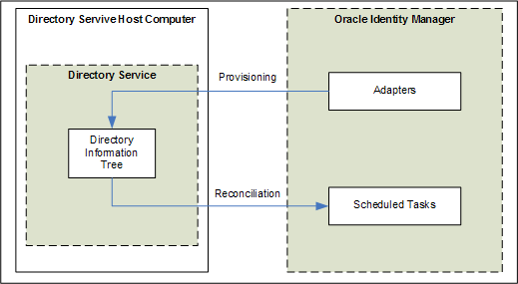
The connector can be configured to run in one of the following modes:
- Account Management
Account management is also known as target resource management. This mode of the connector enables the following operations:
- Provisioning
Provisioning involves creating or updating schema mapping on the target system through Oracle Identity Manager. When you allocate (or provision) a Enterprise Security User resource to an OIM User, the operation results in the creation of an schema mapping on the Directory Service for that user. In the Oracle Identity Manager context, the term “provisioning” is also used to mean updates made to the target system schema mapping through Oracle Identity Manager.
Schema mappings are organized in hierarchical format on the target system. Before you can provision schema mappings to (that is, create mappings in) the required Enterprise Security Domains on the target system, you must fetch into Oracle Identity Manager the list of domains used on the target system. This is achieved by using a lookup synchronization scheduled task.
The connector enables Enterprise Security Role assignment provisioning operations in which you set or change the target system role membership profiles of accounts.
- Target resource reconciliation
The connector applies filters to locate schema mappings to be reconciled from the target system and then fetches the attribute values of these mappings.

Other Major Features of the Connector
The following are other major features of the connector:
- The connector is compatible with high-availability target system environments. You can store information about backup target system hosts in an Oracle Identity Manager target system feature descriptor. If the connector is unable to connect to the primary host, then it tries to connect to one of the hosts listed in the descriptor.

Lookup Fields Used During Connector Operations
During a provisioning operation, you use a lookup field on the process form to specify a single value from a set of values. For example, you use the Country lookup field to select a country from the list of countries in the lookup field. When you deploy the connector, lookup definitions corresponding to the lookup fields on the target system are created in Oracle Identity Manager. Lookup field synchronization involves copying additions or changes made to the target system lookup fields into the lookup definitions in Oracle Identity Manager.
The “Lookup Definition” column of Table 1-2 lists the Oracle Identity Manager lookup definitions that correspond to target system lookup fields listed in the “Target System Field” column of the table.
Table 1-2 Lookup Definitions Synchronized with the Target System
Lookup Definition | Target System Field | Scheduled Task for Synchronization
EUS.Domain | The distinguished Name field of Enterprise Security Domains | You use the EUS Domain Lookup Reconciliation scheduled task to synchronize this lookup definition. This scheduled task is discussed in “Scheduled Tasks for Lookup Field Synchronization“.
EUS.Role | The distinguished Name field of Enterprise Security Roles | You use the GDS Role Lookup Reconciliation scheduled task to synchronize this lookup definition. This scheduled task is discussed in “Scheduled Tasks for Lookup Field Synchronization“.
Table 1-3 describes the other lookup definitions that are created in Oracle Identity Manager when you deploy the connector. These lookup definitions are either pre-populated with values or values must be entered in them after the connector is deployed.
Table 1-3 Other Lookup Definitions
Lookup Definition | Description of Values | Method to Specify Values for the Lookup Definition
ISO.Country | Country codes and names | You manually add or update entries in this lookup definition based on the values in the Country lookup field on the target system.  This lookup definition is discussed in “Configuring the ISO.Country Lookup Definition“.
ISO.Language | Language codes and names | You manually add or update entries in this lookup definition based on the values in the Language lookup field on the target system.  This lookup definition is discussed in “Configuring the ISO.Language Lookup Definition”.
ISO.TimeZone | Time Zone codes and names | You manually add or update entries in this lookup definition based on the values in the Country lookup field on the target system.  This lookup definition is discussed in “Configuring”.

Target Resource Reconciliation
Target resource reconciliation involves fetching data about newly created or modified schema mappings on the target system and using this data to add or modify resources assigned to OIM Users.
The EUS Domain Schema Reconciliation scheduled task is used to initiate a target resource reconciliation run. This scheduled task is discussed in “Scheduled Tasks for Target Resource Reconciliation”.
See Also
The “Reconciliation” section in Oracle Identity Manager Connector Concepts for conceptual information about target resource reconciliation

This section discusses the following topics:
- User Fields for Target Resource Reconciliation
- Reconciliation Rules for Target Resource Reconciliation
- Reconciliation Action Rules for Target Resource Reconciliation

User Fields for Target Resource Reconciliation
Table 1-4 lists the user identity fields whose values are fetched during a target resource reconciliation run.
Table 1-4 User Fields for Target Resource Reconciliation
Process Form Field | Source System Field | Description
Directory Hierarchy | The superior distinguished Name is extracted from the distinguished Name value. | Superior name on the target system
User ID | uid  This is a mandatory field. | User identifier name on the target system
Type | employeeType | Employee Type
… TBD
Group Name | memberOf | Distinguished names of the groups to which a account belongs

Reconciliation Rules for Target Resource Reconciliation
See Also
Oracle Identity Manager Connector Concepts for generic information about reconciliation matching and action rules
The following is the process matching rule:
Rule name: Target Resource Recon Rule
Rule element: User Login Equals User ID
In this rule:
- User Login is the User ID field on the OIM User form.
- User ID is the cn or uid field of Directory Service.
After you deploy the connector, you can view the reconciliation rule for target resource reconciliation by performing the following steps:
Note:
Perform the following procedure only after the connector is deployed.
- Log in to the Oracle Identity Manager Design Console.
- Expand Development Tools.
- Double-click Reconciliation Rules.
- Search for GDS Target Account Match.
Figure 1-3 shows the reconciliation rule for target resource reconciliation.
Figure 1-3 Reconciliation Rule for Target Resource Reconciliation
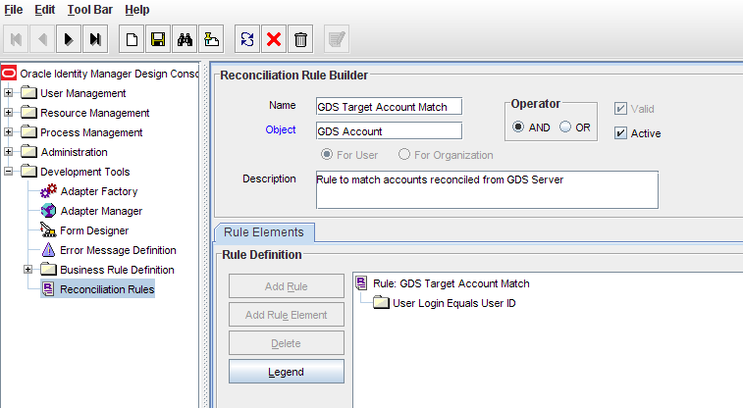

Reconciliation Action Rules for Target Resource Reconciliation
Table 1-5 lists the action rules for target resource reconciliation.
Table 1-5 Action Rules for Target Resource Reconciliation
Rule Condition | Action
No Matches Found | Assign to Administrator With Least Load
One Entity Match Found | Establish Link
One Process Match Found | Establish Link

Note:
No action is performed for rule conditions that are not predefined for this connector. You can define your own action rule for such rule conditions. See Oracle Identity Manager Design Console Guide for information about modifying or creating reconciliation action rules.
After you deploy the connector, you can view the reconciliation action rules for target resource reconciliation by performing the following steps:
- Log in to the Oracle Identity Manager Design Console.
- Expand Resource Management.
- Double-click Resource Objects.
- Search for and open the GDS Account resource object.
- Click the Object Reconciliation tab, and then click the Reconciliation Action Rules tab. The Reconciliation Action Rules tab displays the action rules defined for this connector. Figure 1-4 shows the reconciliation action rule for target resource reconciliation.
Figure 1-4 Reconciliation Action Rules for Target Resource Reconciliation
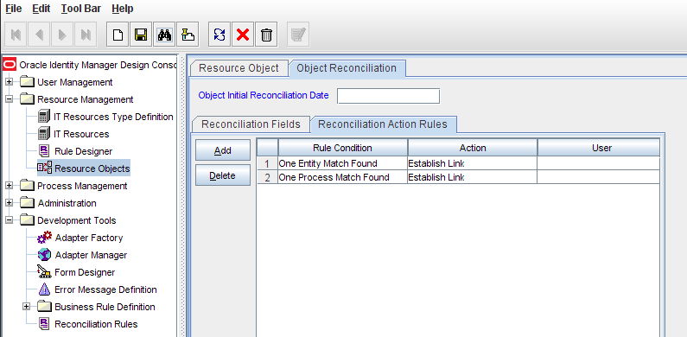

Provisioning
Provisioning involves creating or modifying user data on the target system through Oracle Identity Manager.
See Also
The “Provisioning” section in Oracle Identity Manager Connector Concepts for conceptual information about provisioning
This section discusses the following topics:
- User Provisioning Functions Supported by the Connector
- User Fields for Provisioning

User Provisioning Functions Supported by the Connector
Table 1-6 lists the supported user provisioning functions and the adapters that perform these functions. The functions listed in the table correspond to either a single or multiple process tasks.
See Also
Oracle Identity Manager Connector Concepts for generic information about process tasks and adapters
Table 1-6 User Provisioning Functions Supported by the Connector
Function | Action
Create a user account | GDS Create Account
Delete a user account | GDS Delete Account
Enable a disabled user account | GDS Enable Account
Disable a enabled user account | GDS Disable Account
Update the first name | GDS Change Attribute
Update the last name | GDS Change Attribute
Update the password | GDS Change Password
Add a user account to a group | GDS Add Account To Group
Remove a user account from a group | GDS Remove Account From Group

User Fields for Provisioning
Table 1-7 lists the user identity fields of the target system for which you can specify or modify values during provisioning operations. The Remote Manager is used to implement the provisioning of Terminal Services Profile fields.
Note:
The adapters listed in the Adapter column of the table are used during Update User provisioning operations. During a Create User provisioning operation, the GDS Create Account adapter is used to populate values in all the target system user fields.
Table 1-7 User Fields for Provisioning
<insert table description>
Table 1-8 lists special characters that are supported in process form fields.
Table 1-8 Special Characters Supported in Process Form Fields
Name of the Character | Character
Ampersand | &
asterisk | *
at sign | @
Caret | ^
Comma | ,
Dollar sign | $
Equal sign | =
exclamation point | !
hyphen | -
Left brace | {
Left bracket | [
Left parenthesis | (
number sign | #
percent sign | %
Period | .
plus sign | +
question mark | ?
right brace | }
right bracket | ]
right parenthesis | )
Slash | /
Underscore | _

Trusted Source Reconciliation
Trusted source reconciliation involves fetching data about newly created or modified accounts on the target system and using that data to create or update OIM Users.
The GDS Trusted Account Reconciliation scheduled task is used to initiate a trusted source reconciliation run. This scheduled task is discussed in “Scheduled Tasks for Trusted Resource Reconciliation”.
See Also
The “Reconciliation “section in Oracle Identity Manager Connector Concepts for conceptual information about trusted source reconciliation
This section discusses the following topics:
- User Fields for Trusted Source Reconciliation
- Reconciliation Rule for Trusted Source Reconciliation
- Reconciliation Action Rules for Trusted Source Reconciliation
- Organization Reconciliation

User Fields for Trusted Source Reconciliation
Table 1-9 lists the user identity fields whose values are fetched from the target system during a trusted source reconciliation run.
Table 1-9 User Fields for Trusted Source User Reconciliation
<insert table description>

Reconciliation Rule for Trusted Source Reconciliation
See Also
Oracle Identity Manager Connector Concepts for generic information about reconciliation matching and action rules
The following is the entity matching rule:
Rule Name | Trusted Source Recon Rule
Rule | Login Equals User ID
In this rule:
- User Login is the User ID field on the OIM User form.
- User ID is the cn field of Directory Service
After you deploy the connector, you can view the reconciliation rule for trusted source reconciliation by performing the following steps:
- Log in to the Oracle Identity Manager Design Console.
- Expand Development Tools.
- Double-click Reconciliation Rules.
- Search for GDS Trusted Account Match. Figure 1-5 shows the reconciliation rule for trusted source reconciliation.
Figure 1-5 Reconciliation Rule for Trusted Source Reconciliation
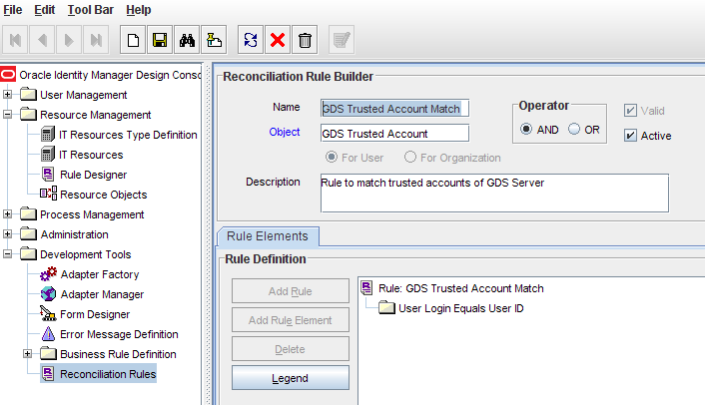

Reconciliation Action Rules for Trusted Source Reconciliation
Table 1-10 lists the action rules for trusted resource reconciliation.
Table 1-10 Action Rules for Trusted Source Reconciliation
Rule Condition | Action
No Matches Found | Create User
One Entity Match Found | Establish Link
One Process Match Found | Establish Link

Note:
No action is performed for rule conditions that are not predefined for this connector. You can define your own action rule for such rule conditions. See Oracle Identity Manager Design Console Guide for information about modifying or creating reconciliation action rules.
After you deploy the connector, you can view the reconciliation action rules for target resource reconciliation by performing the following steps:
- Log in to the Oracle Identity Manager Design Console.
- Expand Resource Management.
- Double-click Resource Objects.
- Search for and open the GDS Trusted Account resource object.
- Click the Object Reconciliation tab, and then click the Reconciliation Action Rules tab. The Reconciliation Action Rules tab displays the action rules defined for this connector. Figure 1-6 shows the reconciliation action rule for trusted resource reconciliation.
Figure 1-6 Reconciliation Action Rules for Trusted Resource Reconciliation
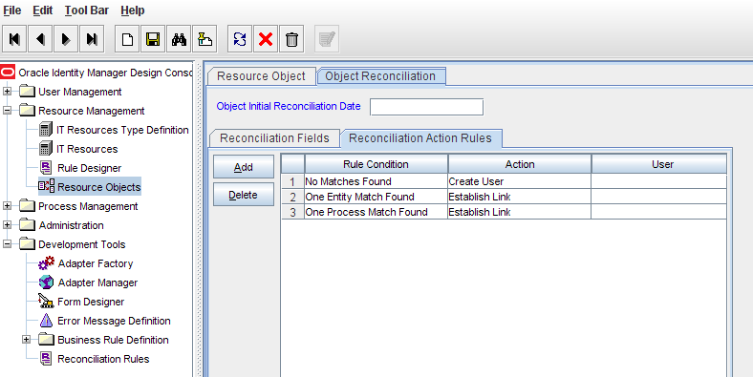

Organization Reconciliation
As mentioned earlier, trusted source reconciliation fetches data about target system users into Oracle Identity Manager. This data is used to create or update records of OIM Users. You can configure trusted source reconciliation so that newly created OIM Users are placed in OIM Organizations that correspond to users' organizations on the target system. To enable this feature, you set the value of the Maintain Hierarchy attribute of the trusted source reconciliation scheduled task (GDS Trusted Account Reconciliation) to yes.
Note:
The scheduled tasks mentioned in this section are discussed in detail in “Scheduled Tasks for Trusted Source Reconciliation”.
To ensure that OIM Organizations corresponding to the target system organizations are created and ready for user data fetched during a trusted source reconciliation run, the organization reconciliation scheduled task (GDS Organization Reconciliation) must be run before the scheduled task for trusted source reconciliation. When the GDS Organization Reconciliation scheduled task is run, data about target system organizations is fetched and used to create OIM Organizations.
Note:
It is recommended that you set the Maintain Hierarchy attribute to yes only if this option is acceptable in your operating environment. Otherwise, the default option of the Maintain Hierarchy attribute set to no must be used while running the trusted source reconciliation scheduled task.
The GDS Organization Reconciliation scheduled task is independent of the organization lookup synchronization scheduled task (GDS Organization Lookup Reconciliation), which is used only in the account management mode.
OIM Organizations cannot completely model the organizational structure that is found on the target system because:
although parent-child hierarchical relationships between organizations are supported in Oracle Identity Manager, the OIM Organizations namespace is a flat namespace. Therefore, two target system OUs that have the same name cannot be re-created in Oracle Identity Manager, even if their parent OUs is different.
In Oracle Identity Manager, organization names cannot contain special characters such as the equal sign (=) and the comma (,). This does not permit the reconciliation of fully qualified distinguished names (FQDNs) of target system OUs into Oracle Identity Manager.
Organization reconciliation does not cover reconciliation of updates to existing organizations on the target system. If you modify the name of an organization on the target system, then it is reconciled as a new organization in Oracle Identity Manager.
See Also
“Guidelines on Configuring Reconciliation” for detailed information about guidelines on configuring organization reconciliation. Some of the points mentioned earlier are repeated in that section.
Table 1-11 lists the organization fields whose values are fetched from the target system during organization reconciliation.
Table 1-11 Organization Fields for Trusted Source Organization Reconciliation
<insert table description>
The following is the reconciliation rule for organization reconciliation:
Rule Name | Organization Recon
Rule | Organization Name Equals Organizations.Organization Name
In this rule:
- Organization Name is the Organization Name field on the Xellerate Organization form.
- Organizations.Organization Name is the Organization Name field of the Directory Service.
Table 1-12 lists the action rules for organization reconciliation.
Table 1-12 Action Rules for Organization Reconciliation
Rule Condition | Action
No Matches Found | Create Organization
One Entity Match Found | Establish Link
One Process Match Found | Establish Link

Roadmap for Deploying and Using the Connector
The following is the organization of information in the rest of this guide:
- Deploying the Connector
describes procedures that you must perform on Oracle Identity Manager and the target system during each stage of connector deployment.
- Extending the Functionality of the Connector
describes procedures that you can perform if you want to extend the functionality of the connector.
- Using the Connector
describes guidelines on using the connector and the procedure to configure reconciliation runs and perform provisioning operations.
- Testing the Connector
- Character Lengths of Target System Fields and Process Form Fields
provides information about the differences in lengths of target system fields and process form fields. This appendix also describes the procedure to change the lengths of process form fields.
- Special Characters Supported for Passwords
lists special characters that you can use in the Password field on the target system and Oracle Identity Manager.
- Sample Transformation Class
provides the code for a sample Java class. You can use this sample class to create a class for transforming reconciled data according to your requirements.

Deploying the Connector
The procedure to deploy the connector can be divided into the following stages:
- Preinstallation
- Installation
- Postinstallation

Preinstallation
Preinstallation information is divided across the following sections:
- Preinstallation on Oracle Identity Manager
- Preinstallation on the Target System

Preinstallation on Oracle Identity Manager
This section contains the following topics:
- Files and Directories On the Installation Media
- Determining the Release Number of the Connector

Files and Directories On the Installation Media
The contents of the connector installation media directory are described in Table 2-1.
Table 2-1 Files and Directories On the Installation Media
File in the Installation Media Directory | Description
configuration/connector.xml | This XML file contains configuration information that is used during the connector installation process.
lib/hst-foundation.jar
Files in the resources directory | Each of these resource bundles contains language-specific information that is used by the connector. During connector installation, these resource bundles are copied into the following directory:  OIM_HOME/xellerate/connectorResources  Note: A resource bundle is a file containing localized versions of the text strings that are displayed on the Administrative and User Console. These text strings include GUI element labels and messages.
xml/gds-base-dm.xml | This XML file contains definitions for the connector components. These components include the following:  - IT Resource Type  - Event Handler
xml/gds-target-dm.xml | This XML file contains definitions for the connector components. These components include the following:  - IT resource  - Resource object  - Process form  - Process task and adapters (along with their mappings)  - Provisioning process  - Prepopulate rules  - Lookup definitions  - Scheduled tasks
xml/gds-trusted-dm.xml

Determining the Release Number of the Connector
You might have a deployment of an earlier release of the connector. While deploying the latest release, you might want to know the release number of the earlier release. To determine the release number of the connector that has already been deployed:
- In a temporary directory, extract the contents of the following JAR file:
OIM_HOME/xellerate/JavaTasks/gds-adapter.jar
- Open the manifest.mf file in a text editor. The manifest.mf file is one of the files bundled inside the gds-adapter.jar file.
In the manifest.mf file, the release number of the connector is displayed as the value of the Version property.

Preinstallation on the Target System
Preinstallation on the target system involves performing the procedure described in the following section.
- Creating a Target System User Account for Connector Operations
Oracle Identity Manager requires a target system user account to access the target system during reconciliation and provisioning operations. You provide the credentials of this user account while performing the procedure described in “Configuring the IT Resource for the Target System“.

Installation
Installation on Oracle Identity Manager consists of the following procedures:
- Running the Connector Installer
- Copying the Connector Files
- Download the ldapbp.jar File
- Configuring the IT Resource for the Target System

Running the Connector Installer

Note:
In this guide, the term Connector Installer has been used to refer to the Connector Installer feature of the Administrative and User Console.
To run the Connector Installer:
- Copy the contents of the connector installation media directory into the following directory:
OIM_HOME/xellerate/ConnectorDefaultDirectory
- Log in to the Administrative and User Console by using the user account described in the “Creating the User Account for Installing Connectors” section of Oracle Identity Manager Administrative and User Console Guide.
- Click Deployment Management, and then click Install Connector.
- From the Connector List, select GDS Directory Service Configuration 1.0.0.0. This list displays the names and release numbers of connectors whose installation files you copy into the default connector installation directory:
OIM_HOME/xellerate/ConnectorDefaultDirectory
If you have copied the installation files into a different directory, then:
- In the Alternative Directory field, enter the full path and name of that directory.
- To repopulate the list of connectors in the Connector List, click Refresh.
- From the Connector List, select GDS Directory Service Configuration 1.0.0.0.
- Click Load.
- To start the installation process, click Continue.
The following tasks are performed, in sequence:
- Configuration of connector libraries
- Import of the connector XML files (by using the Deployment Manager)
- Compilation of adapters
- On successful completion of a task, a check mark is displayed for the task. If a task fails, then an X mark and a message stating the reason for failure is displayed. Depending on the reason for the failure, make the required correction and then perform one of the following steps:
- Retry the installation by clicking Retry.
- Cancel the installation and begin again from Step 0.
- If all three tasks of the connector installation process are successful, then a message indicating successful installation is displayed. In addition, a list of steps that you must perform after the installation is displayed. These steps are as follows:
- Ensuring that the prerequisites for using the connector are addressed
- Configuring the IT resource for the connector
Record the name of the IT resource displayed on this page. The procedure to configure the IT resource is described later in this guide.
- Configuring the scheduled tasks
- Record the names of the scheduled tasks displayed on this page. The procedure to configure these scheduled tasks is described later in this guide.
When you run the Connector Installer, it copies the connector files and external code files to destination directories on the Oracle Identity Manager host computer. These files are listed in Table 2-2.
Table 2-2 Files Copied During Connector Installation
File in the Installation Media Directory | Destination Directory
lib/gds-adapter.jar | OIM_HOME/xellerate/JavaTasks
lib/gds-diagnostic.jar | OIM_HOME/xellerate/JavaTasks
lib/gds-scheduler.jar | OIM_HOME/xellerate/ScheduleTask
lib/gds-common.jar | OIM_HOME/xellerate/ThirdParty
lib/ldapbp.jar | OIM_HOME/xellerate/ThirdParty
Files in the resources directory | OIM_HOME/xellerate/connectorResources

Installing the Connector in an Oracle Identity Manager Cluster
While installing the connector in a clustered environment, you must copy all the JAR files and the contents of the resources directory into the destination directories on each node of the cluster. See Table 2-2 for information about the files that you must copy and their destination locations on the Oracle Identity Manager host computer.

Copying the Connector Files
Table 2-3 lists the files that you must copy to the Oracle Identity Manager host computer.
Note:
The directory paths given in the first column of this table correspond to the location of the connector files on the installation media. See “Media” for more information about these files.
If a particular destination directory does not already exist on the Oracle Identity Manager host computer, then create it.
Table 2-3 Files to Be Copied to the Oracle Identity Manager Host Computer
File in the Installation Media Directory | Destination Directory
lib/gds-adapter.jar | OIM_HOME/xellerate/JavaTasks
lib/gds-diagnostic.jar | OIM_HOME/xellerate/JavaTasks
lib/gds-scheduler.jar | OIM_HOME/xellerate/ScheduleTask
lib/gds-common.jar | OIM_HOME/xellerate/ThirdParty
lib/ldapbp.jar | OIM_HOME/xellerate/ThirdParty

Download the ldapbp.jar File
The ldapbp.jar file is used by the connector to enable LDAP-based search of user records on the target system. You must download this file from the Sun Web site and copy it into the ThirdParty directory as follows:
- Log on the Sun Web site at
http://java.sun.com/products/jndi/downloads/index.html
- Click Download JNDI 1.2.1 & More.
- From the table on the page that is displayed, select and download the ldap-1_2_4.zip file.
- Extract the contents of the ZIP file and copy the ldapbp.jar file from the lib directory to the OIM_HOME/xellerate/ThirdParty directory.
Note:
In an Oracle Identity Manager cluster, copy this JAR file into the ThirdParty directory on each node of the cluster.

Configuring the IT Resource for the Target System
The IT resource for the target system is created during connector installation. This IT resource contains connection information about the target system. Oracle Identity Manager uses this information during reconciliation and provisioning.
You must specify values for the parameters of the GDS Server IT resource as follows:
- Log in to the Administrative and User Console.
- Expand Resource Management.
- Click Manage IT Resource.
- In the IT Resource Name field on the Manage IT Resource page, enter GDS Server and then click Search. Figure 2-1 shows the Manage IT Resource page.
Figure 2-1 Manage IT Resource Page
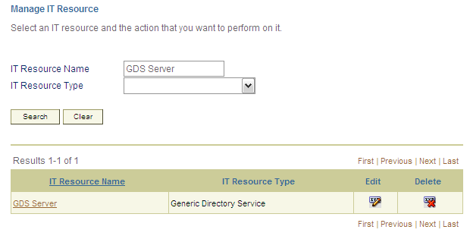
- Click the edit icon for the IT resource.
- From the list at the top of the page, select Details and Parameters.
- Specify values for the parameters of the IT resource. Figure 2-2 shows the Edit IT Resource Details and Parameters page.
Figure 2-2 Edit IT Resource Details and Parameters Page
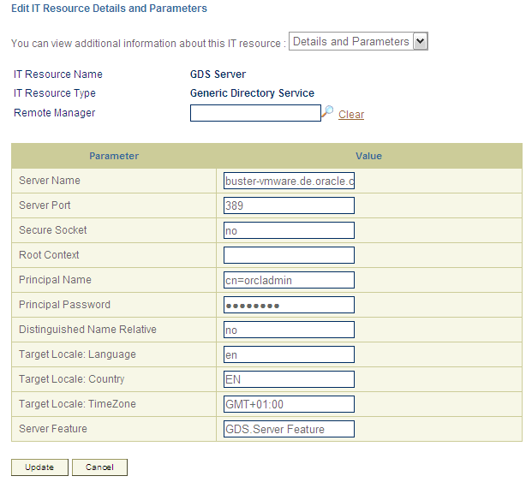
Table 2-4 describes each parameter of the IT resource.
Table 2-4 Parameters of the IT Resource for the Target System
Parameter | Description
Server Name | Enter the host name or IP address of the Directory Service computer (target system host computer) on which Directory Service is installed.  Sample values:  w2khost  172.20.55.120
Server Port | Enter the number of the port at which SSL is running on the target system host computer.  Sample values:  - 636  if the Secure Socket parameter is set to yes  - 389,  if the Secure Socket parameter is set to no  The Use SSL parameter is described later in this table. This parameter is also mentioned in “Configuring SSL for Directory Service“.
Secure Socket | Enter yes to specify that you will configure SSL between Oracle Identity Manager and the target system. Otherwise, enter no.  Default value: no
Root Context | Enter the base DN on which reconciliation of deleted user data and provisioning are to be carried out.  Sample values:  dc=example,dc=com
Principal Name | Enter the fully qualified domain name of the user account that you create by performing the procedure described in “Creating a Target System User Account for Connector Operations”.  You must use the following formats to enter the domain name:  cn=user_login,cn=Users,dc=domain,dc=com  Sample values:  cn=OIMadmin,cn=Users,dc=domain,dc=com
Principal Password | Enter the password of the user account that you create by performing the procedure described in “Creating a Target System User Account for Connector Operations”.
Distinguished Name Relative | Use this parameter as follows to specify whether you want the GDS.Group, GDS.Role and GDS.Server Hierarchy lookup definitions to be populated with distinguished names (DNs) or relative DNs during lookup field synchronization:  - Enter yes if you want the lookup fields to be populated with the DNs.  - Enter no if you want the lookup fields to be populated with the relative DNs.  Default value: no  Note:  The value of this parameter is used during lookup field synchronization, provisioning, and reconciliation. After a lookup field synchronization run, you must not change the value of this parameter. This point is also mentioned in “Guidelines on Using the Connector“.
Locale Language | Default value: en
Locale Country | Default value: US
Locale TimeZone | Default value: GMT+01:00
Server Feature | Default value: GDS.Server Feature
- To save the values, click Update.

Postinstallation
Postinstallation steps are divided across the following sections:
- Postinstallation on Oracle Identity Manager
- Postinstallation on the Target System

Postinstallation on Oracle Identity Manager
Configuring Oracle Identity Manager involves performing the following procedures:
Note:
In a clustered environment, you must perform these procedures on each node of the cluster.

- Clearing Content Related to Connector Resource Bundles from the Server Cache
- Enabling Logging
- Configuring High Availability of the Target System

Clearing Content Related to Connector Resource Bundles from the Server Cache
While you deploy the connector, the resource bundles are copied from the resources directory on the installation media into the OIM_HOME/xellerate/connectorResources directory. Whenever you add a new resource bundle in the connectorResources directory or make a change in an existing resource bundle, you must clear content related to connector resource bundles from the server cache.
To clear content related to connector resource bundles from the server cache:
- In a command window, change to the OIM_HOME/xellerate/bin directory.
Note:
You must perform Step 1 before you perform Step 2. An exception is thrown if you run the command described in Step 2 as follows:
OIM_HOME/xellerate/bin/BATCH_FILE_NAME
- Enter one of the following commands:
On Microsoft Windows:
PurgeCache ConnectorResourceBundle
On UNIX:
PurgeCache.sh ConnectorResourceBundle
Note:
You can ignore the exception that is thrown when you perform Step 2. This exception is different from the one mentioned in Step 1.
In this command, ConnectorResourceBundle is the content category that you must delete from the server cache.
See Also
The following file for information about content categories:
OIM_HOME/config/xlconfig.xml

Enabling Logging
When you enable logging, Oracle Identity Manager automatically stores in a log file information about events that occur during the course of provisioning and reconciliation operations. To specify the type of event for which you want logging to take place, you can set the log level to one of the following:
- ALL
This level enables logging for all events.
- DEBUG
This level enables logging of information about fine-grained events that are useful for debugging.
- INFO
This level enables logging of informational messages that highlight the progress of the application at coarse-grained level.
- WARN
This level enables logging of information about potentially harmful situations.
- ERROR
This level enables logging of information about error events that may still allow the application to continue running.
- FATAL
This level enables logging of information about very severe error events that could cause the application to stop functioning.
- OFF
This level disables logging for all events.
The file in which you set the log level and the log file path depend on the application server that you use:
- BEA WebLogic
To enable logging:
Add the following line in the OIM_HOME/xellerate/config/log.properties file:
log4j.logger.OIM.DIRECTORYSERVICE.PROVISIONING=log_level
log4j.logger.OIM.DIRECTORYSERVICE.RECONCILAITION=log_level
In this line, replace log_level with the log level that you want to set.
for example:
log4j.logger.OIM.DIRECTORYSERVICE.RECONCILAITION=INFO
After you enable logging, the log information is displayed on the server console.
- Oracle Application Server
To enable logging:
Add the following line in the OIM_HOME/xellerate/config/log.properties file:
log4j.logger.OIM.DIRECTORYSERVICE.PROVISIONING=log_level
log4j.logger.OIM.DIRECTORYSERVICE.RECONCILAITION=log_level
In this line, replace log_level with the log level that you want to set.
for example:
log4j.logger.OIM.DIRECTORYSERVICE.RECONCILAITION=INFO
After you enable logging, log information is written to the following file:
ORACLE_HOME/opmn/logs/default_group~home~default_group~1.log
- IBM WebSphere Application Server
To enable logging:
Add the following line in the OIM_HOME/xellerate/config/log.properties file:
log4j.logger.OIM.DIRECTORYSERVICE.PROVISIONING=log_level
log4j.logger.OIM.DIRECTORYSERVICE.RECONCILAITION=log_level
In these lines, replace log_level with the log level that you want to set.
For example:
log4j.logger.OIM.DIRECTORYSERVICE.RECONCILAITION=INFO
After you enable logging, log information is written to the following file:
WEBSPHERE_HOME/AppServer/logs/SERVER_NAME/SystemOut.log
- JBoss Application Server
To enable logging:
In the JBOSS_HOME/server/default/conf/jboss-log4j.xml file, locate the following lines:
<category name=“OIM. DIRECTORYSERVICE.PROVISIONING”>
<priority value=“log_level”/>
</category>
<category name=“OIM. DIRECTORYSERVICE.RECONCILAITION “>
<priority value=“log_level”/>
</category>
In the second XML code lines of each set, replace log_level with the log level that you want to set. For example:
<category name=“OIM. DIRECTORYSERVICE.RECONCILAITION “>
<priority value=“INFO”/>
</category>
After you enable logging, log information is written to the following file:
JBOSS_HOME/server/default/log/server.log

Configuring High Availability of the Target System
Suppose you have set up multiple, replicated installations of the target system for high availability. You can use the GDS.Backup Server lookup definition to ensure that if the primary target system installation becomes unavailable, then Oracle Identity Manager switches to one of the secondary target system installations. The GDS.Backup Server lookup definition is one of the lookup definitions created when you deploy the connector.
For a single primary installation, you can have any number of secondary installations. In addition, if you configure the connector to work with multiple primary installations, then you can specify secondary installations for each primary installation.
To use the GDS.Backup Server lookup definition, open it in the Design Console and enter code key and decode values for each combination of primary and secondary target system installation.
See Also
Oracle Identity Manager Design Console Guide for information about working with lookup definitions
Table 2-5 shows samples entries for the GDS.Backup Server lookup definition.
Table 2-5 Samples Entries for the GDS.Backup Server Lookup Definition
Code Key | Decode
keaton.vm.oracle.com | 3060
laurel.vm.oracle.com | 3060

In this table, the first two entries represent two secondary installations (192.168.63.66 and 192.168.63.67) for one primary installation defined on the IT Resource.

Postinstallation on the Target System
Postinstallation on the target system consists of the following procedure.
In the Directory Service, the “<Directory Password Policy>“policy setting is used to enable or disable password policies.
The procedure that you must perform depends on whether or not you want to achieve either or both of the following objectives:
The procedure that you must perform depends on whether or not you want to achieve either or both of the following objectives:
- Enable password policies
- Configure SSL between Oracle Identity Manager and the target system
Note:
The procedure to configure SSL is discussed later in this guide.
Suppose there is a password policy on the target system for enforcing that the password field of user accounts is never left empty. At the same time, suppose you do not configure SSL. Under these conditions, the target system would reject provisioning operations that leave the password field empty. Therefore, you would not be able to perform such provisioning operations from Oracle Identity Manager. To enable provisioning operations under these conditions, you must disable password policies on the target system.
If you configure SSL and you want to enable both the default Directory password policy and a custom password policy, then you must enable the “<Directory Password Policy>“policy setting.
To enable or disable the “<Password Policy>“policy setting:

Configuring SSL for Directory Service
To configure SSL communication between Oracle Identity Manager and Directory Service, you must perform the following tasks:
- Generating the Certificate in Directory Service
- Setting Up the Target System Certificate As a Trusted Certificate

Generating the Certificate in Directory Service
To generate the certificate in Directory Service, perform the following procedures:
- Submitting a Request for the Certificate
- Issuing the Certificate
- Adding the Certificate to the Personal Store of the Directory Service
- Assigning Permissions to the Certificate Key
- Restarting the Directory Service Instance
- Testing the Certificate

Submitting a Request for the Certificate
TDB

Issuing the Certificate
TDB

Adding the Certificate to the Personal Store of the Directory Service
TDB

Assigning Permissions to the Certificate Key
TDB

Restarting the Directory Service Instance
TDB

Testing the Certificate
TDB

Setting Up the Target System Certificate As a Trusted Certificate
If the Directory Service certificate is not issued or certified by a CA, then set it up as a trusted certificate. To do this, you first export the certificate and then import it into the keystore of the Oracle Identity Manager host computer as a trusted CA certificate.
To export the Directory Service certificate:
TBD
To import the target system certificate into the certificate store of the Oracle Identity Manager host computer:
Note:
All application server releases supported by Oracle Identity Manager release 9.1.0 are supported.
In a clustered environment, you must perform this procedure on all the nodes of the cluster.
- Copy the target system certificate to the Oracle Identity Manager host computer.
- Change to the directory where you copy the certificate file, and then enter a command similar to the following:
keytool -import -alias ALIAS -file CER_FILE -keystore MY_CACERTS -storepass PASSWORD
In this command:
Alias | is the alias for the certificate (for example, the server name).
CER_FILE | is the full path and name of the certificate (.cer) file.
Table 2-7 shows the location of the certificate store for each of the supported application servers.
Table 2-7 Certificate Store Locations
Application Server | Certificate Store Location
BEA WebLogic Server | - If you are using BEA jrockit_R27.3.1-jdk, then copy the certificate into the following directory:  JROCKIT_HOME/jre/lib/security  - If you are using the default BEA WebLogic Server JDK, then copy the certificate into the following directory:  WEBLOGIC_HOME/java/jre/lib/security/cacerts
Oracle Application Server | ORACLE_HOME/jdk/jre/lib/security/cacerts
IBM WebSphere Application Server | - For a no clustered configuration of any supported IBM WebSphere Application Server release, import the certificate into the following certificate store:  WEBSPHERE_HOME/java/jre/lib/security/cacerts  - For IBM WebSphere Application Server 6.1.x, in addition to the cacerts certificate store, you must import the certificate into the following certificate store:  WEBSPHERE_HOME/AppServer/profiles/SERVER_NAME/config/cells/CELL_NAME/nodes/NODE_NAME/trust.p12  For example:  C:\Program Files\IBM\WebSphere\AppServer\profiles\AppSrv02\config\cells\wkslaurel3224Node02Cell\nodes\wkslaurel3224Node02\trust.p12  - For IBM WebSphere Application Server 5.1.x, in addition to the cacerts certificate store, you must import the certificate into the following certificate store:  WEBSPHERE_HOME/etc/DummyServerTrustFile.jks
JBoss Application Server | JAVA_HOME/jre/lib/security/cacerts
- To confirm whether or not the certificate has been imported successfully, enter a command similar to the following:
keytool -list -alias ALIAS -keystore MY_CACERTS -storepass PASSWORD
For example:
keytool -list -alias MyAlias -keystore C:\mydir\java\jre\lib\security\cacerts -storepass changeit
- For a no clustered configuration of IBM WebSphere Application Server, download the jsse.jar file from the Sun Web site and copy this file into the WEBSPHERE_HOME/java/jre/lib/ext directory.
- For a clustered configuration of IBM WebSphere Application Server, download the jnet.jar, jsse.jar, and jcert.jar files from the Sun Web site and copy these files into the WEBSPHERE_HOME/java/jre/lib/ext directory.

Extending the Functionality of the Connector
This chapter describes procedures that you can perform to extend the functionality of the connector for addressing your specific business requirements.
This chapter discusses the following optional procedures:
- See “Mappings” if you want to modify the default field mappings between Oracle Identity Manager and the target system.
- The “Reconciliation” section describes the procedure to add mappings between fields of the target system and Oracle Identity Manager.
- The “Reconciliation” section describes the procedure to add mappings between multivalve fields of the target system and Oracle Identity Manager.
- The following sections describe procedures that are aimed at extending the target resource reconciliation functionality of the connector:
- The “Provisioning” section describes the procedure to add mappings between fields of the target system and Oracle Identity Manager.
- The “Provisioning” section describes the procedure to add mappings between multivalve fields of the target system and Oracle Identity Manager.
- The “Classes” section describes the procedure to add mappings for object classes that you create on the target system.
- The “Options” section describes the procedure to enable the Auto Pre-populate and Auto Save options of the resource object.
- The “Reconciliation” section describes the procedure to add mappings between fields of the target system and Oracle Identity Manager.
- The “Manager” section describes the procedure to modify data that is fetched into Oracle Identity Manager for reconciliation.
- The “Reconciliation” section describes the procedure for using the target system as one of the trusted sources of identity data in your organization.
- The “System” section describes the procedure to configure the connector for multiple installations of the target system.

Modifying Existing Field Mappings
Default mappings between fields of the target system and Oracle Identity Manager are listed in the following sections:
- User Fields for Target Resource Reconciliation
- User Fields for Provisioning
- User Fields for Trusted Source Reconciliation
If you want to modify these mappings, then:
- Log in to the Design Console.
- Expand Administration, and double-click Lookup Definition.
- Search for and open the lookup definition that you want to modify.
Table 3-1 describes the contents of the lookup definitions that store field mapping information for reconciliation and provisioning.
Table 3-1 Lookup Definitions that store field mapping information
Lookup Definition | Contents of the Code Key Column | Contents of the Decode Column
GDS.Group.Reconciliation.Mapping | Names of user fields in the Directory Service | Names of process form fields for Directory accounts
GDS.Group.Reconciliation.Transformation
GDS.Organization.Reconciliation.Mapping
GDS.Organization.Reconciliation.Transformation
GDS.Organization.Reconciliation.Reference
GDS.Organization.Reconciliation.Group Member
GDS.Organization.Reconciliation.Group Member.Transformation
GDS.Organization.Provisioning.Mapping
GDS.Organization.Provisioning.Transformation
GDS.Account.Reconciliation.Mapping | Names of user fields in the Directory Service | Names of process form fields for Directory accounts
GDS.Account.Reconciliation.MultiValue
GDS.Account.Reconciliation.Transformation
GDS.Account.Reconciliation.Lookup Transformation
GDS.Account.Reconciliation.Reference
GDS.Account.Reconciliation.Group Member
GDS.Account.Reconciliation.Group Member.Mapping
GDS.Account.Reconciliation.Group Member.Transformation
GDS.Account.Provisioning.Mapping | Names of process form fields for Directory Service accounts | Names of user fields in the Directory Service
GDS.Account.Provisioning.Transformation
- Make the required change in the field mappings by modifying the Code Key and Decode values.
- Click Save.

Adding New Fields for Target Resource Reconciliation
Note:
If you want to add a multivalve field for target resource reconciliation, then see “Adding New Multivalued Fields for Target Resource Reconciliation”.
By default, the fields listed in Table 1-4 are mapped for reconciliation between Oracle Identity Manager and the target system. If required, you can add new fields for target resource reconciliation.
Before you add a new field for target resource reconciliation, you must first determine the target system name of the field as follows:
Note:
Do not perform the procedure to determine the target system name of the field if it belongs to one of the following user data categories:
- Remote Control
- Sessions
- Environment

- Install the target system schema, if it is not already installed.
Refer to the vendor site for information about installing the schema.
- Open the target system schema.
- Expand the Console Root folder, expand the target system schema, and then double-click Classes.
- Right-click user, and then select Properties.
The Attributes tab displays the attributes (that is, fields) that are currently in use on the target system.
- Note down the name of the field that you want to add, and then click Cancel.
For example, if you want to add the Employee ID field for reconciliation, then note down employeeID.
To add a new field for target resource reconciliation:
See Also
Oracle Identity Manager Design Console Guide for detailed information about these steps
- Log in to the Oracle Identity Manager Design Console.
- Add the new field on the process form as follows:
a. Expand Development Tools.
b. Double-click Form Designer.
c. Search for and open the UD_GDS_USR process form.
d. Click Create New Version, and then click Add.
e. Enter the details of the field.
For example, if you are adding the Employee ID field, enter
UD_GDS_USR_EMP_ID in the Name field and then enter other details
such as Variable Type, Length, Field Label, and Field Type.
f. Click Save, and then click Make Version Active. Figure 3-1 shows the
new field added to the process form.
Figure 3-1 New Field Added to the Process Form
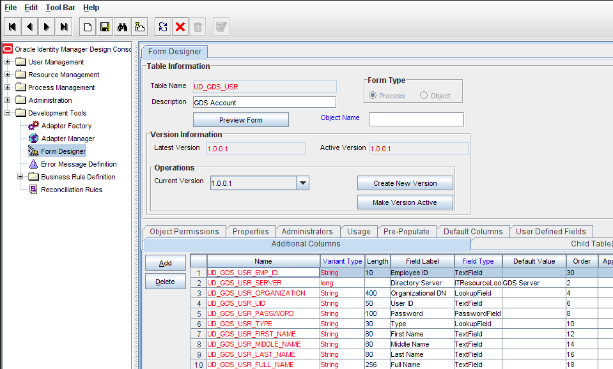
- Add the new field to the list of reconciliation fields in the resource objects as follows:
a. Expand Resource Management.
b. Double-click Resource Objects.
c. Search for and open the GDS Account resource object.
d. On the Object Reconciliation tab, click Add Field.
e. Enter the details of the field.
For example, enter Employee ID in the Field Name field and select
String from the Field Type list.
Later in this procedure, you will enter the field name as the Decode value
of the entry that you create in the lookup definition for reconciliation.
f. Click Save. Figure 3-2 shows the new reconciliation field added to the
resource object.
Figure 3-2 New Reconciliation Field Added in the Resource Object
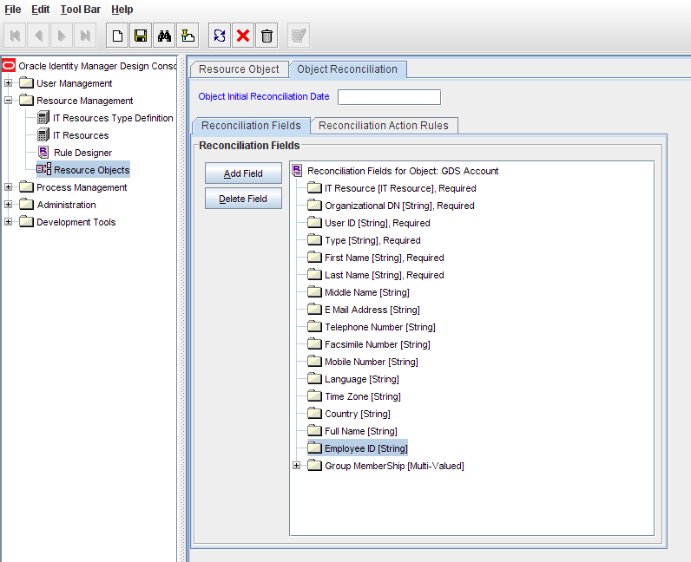
- Create a reconciliation field mapping for the new field in the process definition as follows: :
a. Expand Process Management.
b. Double-click Process Definition.
c. Search for and open the GDS Account Provisioning process definition.
d. On the Reconciliation Field Mappings tab of the GDS Account
Provisioning process definition, click Add Field Map.
e. In the Field Name field, select the value for the field that you want to
add.
f. Double-click the Process Data Field field, and then select
UD_GDS_USR_EMP_ID.
g. Click Save.
Figure 3-3 shows the new reconciliation field mapped to a
process data field in the process definition.
Figure 3-3 New Reconciliation Field Mapped to the Process Data Field
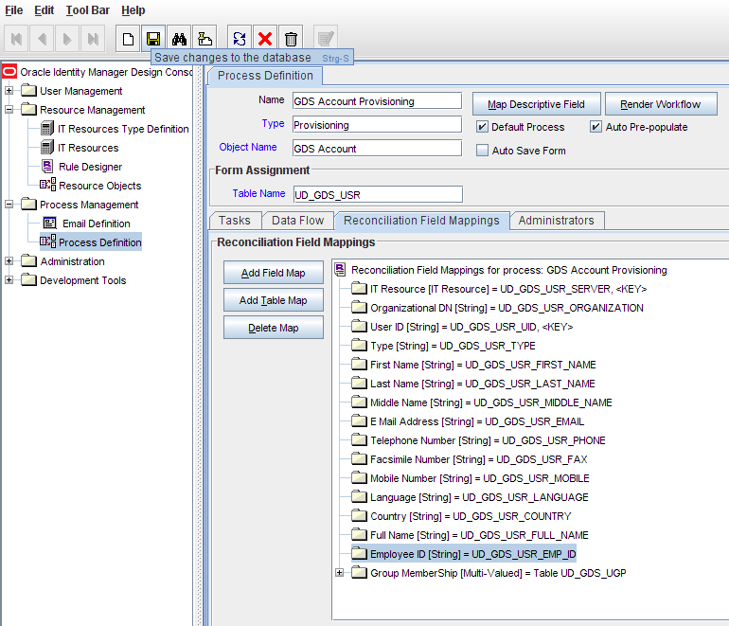
- Create an entry for the field in the lookup definition for reconciliation as follows:
a. Expand Administration.
b. Double-click Lookup Definition.
c. If the field that you want to add is not an Environment, Remote Control,
or Sessions field, then search for and open the following lookup
definition GDS.Account.Reconciliation.Mapping
d. Click Add and enter the Code Key and Decode values for the field. The
Code Key value must be the name of the field on the target system,
which you determined at the start of this procedure. The Decode value is
the name that you provide for the reconciliation field in Step 3.e.
For example, enter employeeID in the Code Key field and then enter
Employee ID in the Decode field.
e. Click Save. Figure 3-4 shows the lookup code added to the lookup
definition.
Figure 3-4 Entry Added in the Lookup Definition
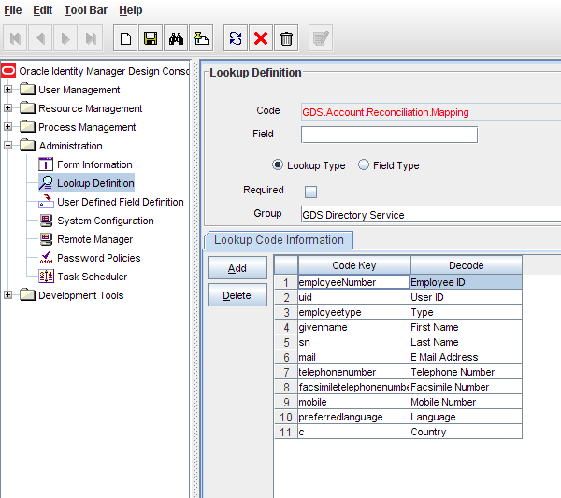

Adding New Multivalued Fields for Target Resource Reconciliation
By default, the multivalve fields listed in Table 1-4 are mapped for reconciliation between Oracle Identity Manager and the target system. If required, you can add new multivalve fields for target resource reconciliation.
To add a new multivalve field for target resource reconciliation:
- Log in to the Oracle Identity Manager Design Console.
- Create a form for the multivalve field as follows:
a. Expand Development Tools.
b. Double-click Form Designer.
c. Create a form by specifying a table name and description, and then click
Save.
d. Click Add and enter the details of the field.
e. Click Save and then click Make Version Active. Figure 3-5 shows the
multivalve field added on a new form.
Figure 3-5 Multivalued Field Added on a New Form
<insert screenshot>
- Add the form created for the multivalve field as a child form of the process form as follows:
a. Search for and open the UD_GDS_USR process form.
b. Click Create New Version.
c. Click the Child Table(s) tab.
d. Click Assign.
e. In the Assign Child Tables dialog box, select the newly created child form, click the right arrow, and then click OK
f. Click Save and then click Make Version Active. Figure 3-6 shows the
child form added to the process form.
Figure 3-6 Child Form Added to the Process Form
<insert screenshot>
- Add the new field to the list of reconciliation fields in the resource objects as follows:
a. Expand Resource Management.
b. Double-click Resource Objects.
c. Search for and open the GDS Account resource object.
d. On the Object Reconciliation tab, click Add Field.
e. In the Add Reconciliation Fields dialog box, enter the details of the field.
For example, enter carLicense in the Field Name field and select Multi
Valued Attribute from the Field Type list.
f. Click Save and then close the dialog box.
g. Right-click the newly created field.
h. Select Define Property Fields.
i. In the Add Reconciliation Fields dialog box, enter the details of the newly
created field.
For example, enter carLicense in the Field Name field and select String
from the Field Type list.
j. Click Save, and then close the dialog box. Figure 3-7 shows the new
reconciliation field added in the resource object.
Figure 3-7 New Reconciliation Field Added in the Resource Object
<insert screenshot>
- Create a reconciliation field mapping for the new field as follows:
a. Expand Process Management.
b. Double-click Process Definition.
c. Search for and open the GDS Account Provisioning process definition.
d. On the Reconciliation Field Mappings tab of the GDS Account
Provisioning process definition, click Add Table Map.
e. In the Add Reconciliation Table Mapping dialog box, select the field
name and table name from the list, click Save, and then close the dialog
box.
f. Right-click the newly created field, and select Define Property Field
Map.
g. In the Field Name field, select the value for the field that you want to
add.
h. Double-click the Process Data Field field, and then select
UD_CAR_LICENSE.
i. Select Key Field for Reconciliation Field Matching and click Save.
Figure 3-8 shows the new reconciliation field mapped to a process data
field in the process definition.
Figure 3-8 New Reconciliation Field Mapped to a Process Data Field
<insert screenshot>
- Create an entry for the field in the lookup definition for reconciliation as follows:
a. Expand Administration.
b. Double-click Lookup Definition.
c. Search for and open the GDS.Account.Reconciliation Mapping lookup
definition
d. Click Add and enter the Code Key and Decode values for the field, and
then Click Save. The Code Key value must be the name of the attribute
field on the target system.
For example, enter carLicense in the Code Key field and then enter
carLicense in the Decode field. Figure 3-9 shows the lookup code added
to the lookup definition.
Figure 3-9 Entry Added in the Lookup Definition
<insert screenshot>
- Add the multivalve field to the GDS.Server Feature lookup definition as follows:
a. Double-click Lookup Definition.
b. Search for and open the GDS.Object Reference.Reconciliation lookup
definition.
c. Add multivalve attributes that are to be reconciled in the Decode field
and click Save. The attributes must be separated by the Decode value
entered in the MultiValueAttributesConfiguration field.
For example, if MultiValueAttributesConfiguration contains the
semicolon (;) as the Decode value, then the Decode value of
MultiValueAttributes must be memberOf;carLicense. In this value, the
semicolon has been used as the delimiter character. Figure 3-10 shows the
multivalve field added to the GDS.Object Reference.Reconciliation
lookup definition.
Figure 3-10 Multivalued Field Added to the Lookup Definition
<insert screenshot>

Adding New Fields for Provisioning
By default, the fields listed in Table 1-7 are mapped for provisioning between Oracle Identity Manager and the target system. If required, you can map additional fields for provisioning.
Before you add a new field for provisioning, you must first determine the target system name of the field as follows:
Note:
Do not perform the procedure to determine the target system name of the field if it belongs to one of the following user data categories:
- Remote Control
- Sessions
- Environment
- Install the target system schema, if it is not already installed.
Refer to the vendor site for information about installing the schema.
- Open the target system schema.
- Expand the Console Root folder, expand the target system schema, and then double-click Classes.
- Right-click user, and then select Properties.
The Attributes tab displays the attributes (that is, fields) that are currently in use on the target system.
- Note down the name of the field that you want to add, and then click Cancel.
For example, if you want to add the Employee ID field for reconciliation, then note down employeeID.

To add a new field for target resource reconciliation:

See Also
Oracle Identity Manager Design Console Guide for detailed information about these steps
- Log in to the Oracle Identity Manager Design Console.
- Add the new field on the process form as follows:
If you have added the field on the process form by performing Step 2 of “Adding New Fields for Target Resource Reconciliation“, then you need not add the field again. If you have not added the field, then:
a. Expand Development Tools.
b. Double-click Form Designer.
c. Search for and open the UD_GDS_USR process form.
d. Click Create New Version, and then click Add.
e. Enter the details of the field.
For example, if you are adding the Employee ID field, enter
UD_GDS_USR_EMP_ID in the Name field and then enter other details
such as Variable Type, Length, Field Label, and Field Type.
f. Click Save, and then click Make Version Active. Figure 3-11 shows the
new field added to the process form.
Figure 3-11 New Field Added to the Process Form
- Create an entry for the field in the lookup definition for provisioning as follows:
a. Expand Administration.
b. Double-click Lookup Definition.
c. If the field that you want to add is not an Environment, Remote Control,
or Sessions field, then search for and open the following lookup
definition GDS.Account.Provisioning.Mapping
d. Click Add and enter the Code Key and Decode values for the field. The
Code Key value must be the name of the field on the target system,
which you determined at the start of this procedure. The Decode value is
the name that you provide for the reconciliation field in Step 3.e.
For example, enter UD_GDS_USR_EMP_ID in the Code Key field and
then enter employeeID in the Decode field.
e. Click Save. Figure 3-12 shows the lookup code added to the lookup
definition.
Figure 3-12 Entry Added in the Lookup Definition
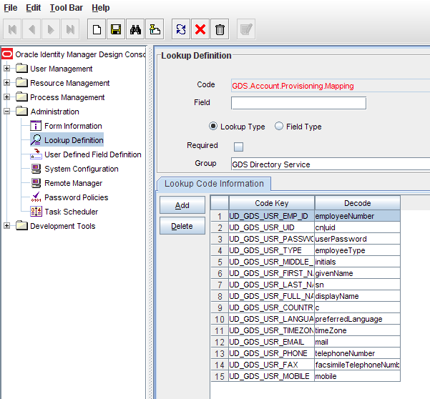

Enabling Update of New Fields for Provisioning
After you add a field for provisioning, you must enable update operations on the field. If you do not perform this procedure, then you will not be able to modify the value of the field after you set a value for it during the Create User provisioning operation.
To enable the update of a new field for provisioning:
See Also
Oracle Identity Manager Design Console Guide for detailed information about these steps
- Log in to the Oracle Identity Manager Design Console.
- In the process definition, add a new task for updating the field as follows:
a. Expand Process Management.
b. Double-click Process Definition, and then open the GDS Account
Provisioning process definition for a user attribute or the GDS Group
Provisioning process definition for a group attribute.
c. Click Add and enter the task name and the task description.
d. In the Task Properties section, select the following fields:
– Conditional
– Required for Completion
– Allow Cancellation while Pending
– Allow Multiple Instances
e. Click Save.
Figure 4–13 shows the new task added to the process definition.
Figure 4–13 New Task Added to the Provisioning Process
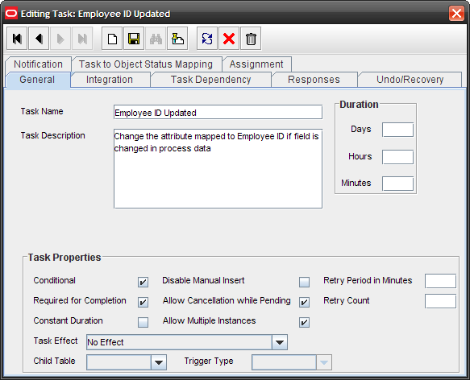
- In the GDS Account Provisioning process definition, select the adapter name in the Handler Type section as follows:
a. Go to the Integration tab, click Add and select Adapter.
b. In the Handler Type section, select
adpGDSUPDATEACCOUNTATTRIBUTE for an account attribute or
adpGDSUPDATEGROUPATTRIBUTE for a group attribute.
c. Click Save.
Figure 4–14 shows the adapter added to the handler.
Figure 4–14 Adapter Added to the Handler
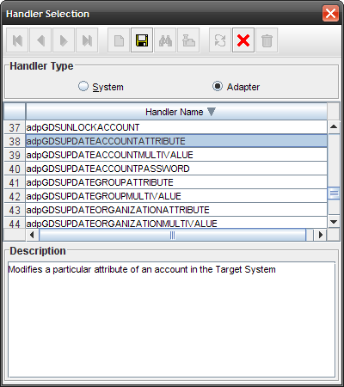
- Double-click the Variable Name field to get the value and map the adapter variable to Response Code Figure 4-15 shows the variable name mapped to Response Code.
Figure 4-15 Adapter Return Value Mapped to Response Code
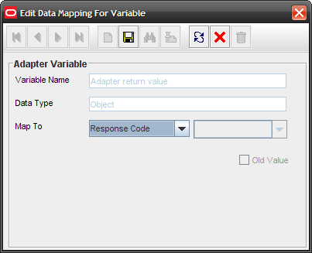
- Double-click the Variable Name field to get the value and map the adapter variable to a process data field. Figure 4-16 shows the variable name mapped to a process data field.
Figure 4-16 Adapter Variable Mapped to a Process Data Field
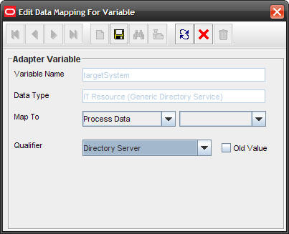
- Double-click the Variable Name field to get the value and map the adapter variable to a process data field. Figure 4-17 shows the adapter variable mapped to a process data field.
Figure 4-17 Adapter Variable Mapped to a Process Data Field
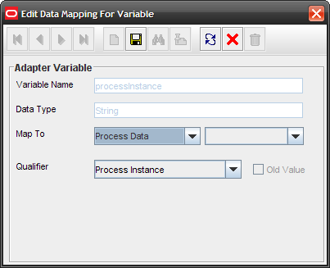
- Double-click the Variable Name field to get the value and map the adapter variable to a process data field. Figure 4-18 shows the adapter variable mapped to a process data field.
Figure 4-18 Adapter Variable Mapped to a Process Data Field
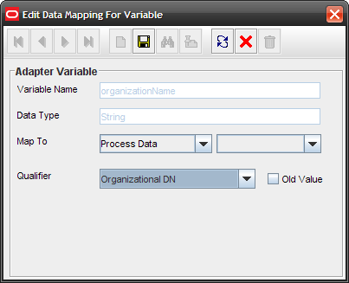
- Double-click the Variable Name field to get the value and map the adapter variable to a process data field. Figure 4-19 shows the adapter variable mapped to a process data field.
Figure 4-19 Adapter Variable Mapped to a Process Data Field
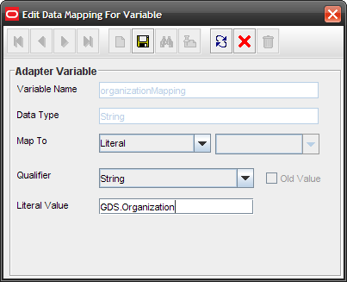
- Double-click the Variable Name field to get the value and map the adapter variable to a process data field. Figure 4-20 shows the adapter variable mapped to a process data field.
Figure 4-20 Adapter Variable Mapped to a Process Data Field
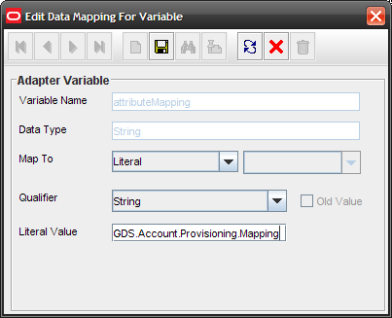
- Double-click the Variable Name field to get the value and map the adapter variable to a process data field. Figure 4-21 shows the adapter variable mapped to a process data field.
Figure 4-21 Adapter Variable Mapped to a Process Data Field
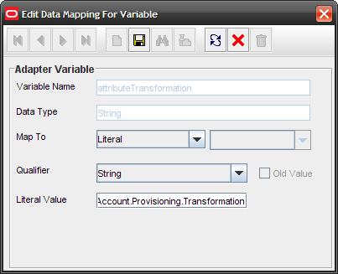
- Double-click the Variable Name field to get the value and map the adapter variable with the corresponding field on the target system, which you determined in the “Adding New Fields for Provisioning”. For example, enter employeeID for updating Employee ID. Figure 4-22 shows the adapter variable mapped to a literal.
Figure 4-22 Adapter Variable Mapped to a Literal
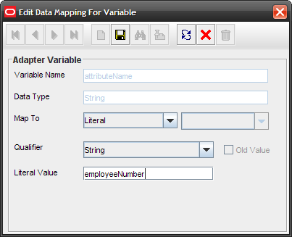
- Click Save.

Adding New Multivalued Fields for Provisioning
To add new multivalve fields for provisioning:
Note:
Before starting the following procedure, perform Steps 1 through 3 as described in the section “Adding New Multivalued Fields for Target Resource Reconciliation”. If these steps have been performed while adding new multivalve fields for target resource reconciliation, then you need not repeat the steps.
- Log in to the Oracle Identity Manager Design Console.
- Expand Process Management.
TBD
- In the process definition, add the task for provisioning multivalve attributes as follows:
TBD
- Select the adapter as follows:
TBD
- Double-click and map the adapter variable to a process data field and click Save. Figure 3-20 shows the adapter variable name mapped to a process data field.
Figure 3-20 Adapter Variable Mapped to a Process Data Field
<insert screenshot>
- Double-click and map the adapter variable to a literal and specify the name of the attribute to be updated in the Literal Value field, and then click Save. Figure 3-21 shows the adapter variable mapped to a literal.
Figure 3-21 Adapter Variable Mapped to a Literal
<insert screenshot>
- Double-click and map the adapter variable to a process data field of the newly created form. If you are removing the attribute, then select Old Value and click Save. Figure 3-22 shows the adapter variable mapped to a process data field.
Figure 3-22 Adapter Variable Mapped to a Process Data Field
<insert screenshot>
- Double-click and map the adapter variable to a process data field and click Save. Figure 3-23 shows the adapter variable name mapped to a process data field.
Figure 3-23 Adapter Variable Mapped to a Process Data Field
<insert screenshot>
- Double-click and map the adapter variable to a response code field and click Save. Figure 3-24 shows the adapter variable name mapped to a response code field.
Figure 3-24 Adapter Variable Mapped to a Response Code Field
<insert screenshot>
- Click Save on Process Task.

Adding Mappings for New Object Classes
To create an object class and add fields of the object class for provisioning:
- Create the object class and assign mandatory and optional attributes to the object class.
Refer to vendor documentation for information about creating the object class.
Note:
Assign the inetOrgPerson object class as the parent of the object class that you create.
- Refresh the schema.
- To add the mandatory and optional attributes of the object class for provisioning, perform the procedure described in “Adding New Fields for Provisioning”.
- Open the GDS.Server Feature lookup definition and change the decode value of the Account Object Class code key value to include the new object class name.
Refer to “Configuring the GDS.Server Feature Lookup Definition” for detailed information about performing this step.

Enabling the Auto Pre-populate and Auto Save Options
Auto Pre-populate and Auto Save are two of the options available in the resource object. You use the Auto Pre-populate option to specify whether a custom form will be populated by Oracle Identity Manager or a user. You use the Auto Save option to specify that Oracle Identity Manager must save the data, without user intervention, in any resource-specific form that was created using the Form Designer form.
See Also
Oracle Identity Manager Design Console Guide for more information about both options
If you want to use either of these options, then specify default values for mandatory check boxes of the process definition as follows:
- Log in to the Design Console.
- Expand Development Tools, and double-click Form Designer.
- Search for and open the GDS Account Provisioning process definition.
- Click Save.

Adding New Fields for Trusted Source Reconciliation
By default, the attributes listed in Table 1-9 are mapped for reconciliation between Oracle Identity Manager and the target system. If required, you can add new fields for trusted source reconciliation.
Before you add a new field for trusted source reconciliation, you must first determine the target system name of the field as follows:
- Install the target system schema, if it is not already installed.
Refer to the vendor site for information about installing the schema.
- Open the target system schema.
- Expand the Console Root folder, expand the target system schema, and then double-click Classes.
- Right-click user, and then select Properties.
The Attributes tab displays the attributes (that is, fields) that are currently in use on the target system.
- Note down the name of the field that you want to add, and then click Cancel.
For example, if you want to add the Employee ID field for reconciliation, then note down employeeID.
To add a new field for trusted source reconciliation:
See Also
Oracle Identity Manager Design Console Guide for detailed information about these steps
- Log in to the Oracle Identity Manager Design Console.
- Add the new field on the process form as follows:
TBD
- Add the new field to the list of reconciliation fields in the resource object as follows:
TBD
- Create a reconciliation field mapping for the new field as follows:
TBD
- Create an entry for the field in the lookup definition for reconciliation as follows:
TBD
- Select Field Type and click Save. Figure 3-30 shows the entry added to the lookup definition.
TBD

Transforming Data Reconciled Into Oracle Identity Manager
This section discusses the Transform Lookup Code and Use Transform Mapping attributes of the scheduled tasks for target resource and trusted source reconciliation, GDS Target Account Reconciliation and GDS Trusted Account Reconciliation.
During reconciliation, you may want to transform the values of some target system fields before they are stored in Oracle Identity Manager. Appending a number at the end of the user ID is an example of a data transformation.
The Transform Lookup Code and Use Transform Mapping attributes provide a method for implementing such transformations. To use these attributes:
- Identify the fields that you want to transform.
- Create the Java file containing the code implementation of the transformation that must be performed during reconciliation.
See Also
Appendix “Sample Transformation Class“
- Compile the Java file. While compiling the file, you must reference the oim-foundation.jar and oim-utility.jar in the OIM_HOME/xellerate/ThirdParty directory.
- Create JAR files containing the code to implement the required transformations on the fields.
- Copy the JAR files into the following directory:
OIM_HOME/xellerate/ThirdParty
- In the GDS.Target Account Tronsformation.Mapping lookup definition, add an entry for the transformation. In the Code Key column, enter the name of the reconciliation field (in the resource object) on which you want the transformation to be performed. In the Decode column, enter the name of the class file. For example
Code Key | First Name
Decode | Reverse

See Also
Oracle Identity Manager Design Console Guide for information about creating lookup definitions

- While configuring the GDS Target Account Reconciliation scheduled task by performing the procedure described in “Scheduled Tasks for Target Resource Reconciliation” and GDS Trusted Account Reconciliation scheduled task by performing the procedure described in “Scheduled Tasks for Trusted Source Reconciliation”:
Enter the name of the lookup definition as the value of the Attribute
Transformation attribute.
Enter yes as the value of the Attribute Transformation Enabled attribute
to specify that you want transformations to be applied. If you enter no as
the value, then the transformations are not applied.

Configuring the Connector for Multiple Trusted Source Reconciliation
The following are examples of scenarios in which there is more than one trusted source for user data in an organization:
- One of the target systems is a trusted source for data about employees. The second target system is a trusted source for data about contractors. The third target system is a trusted source for data about interns.
- One target system holds the data of some of the identity fields that constitute an OIM User. Two other systems hold data for the remaining identity fields. In other words, to create an OIM User, data from all three systems would need to be reconciled.
If the operating environment of your organization is similar to that described in either one of these scenarios, then this connector enables you to use the target system as one of the trusted sources of user data in your organization.
Refer to Oracle Identity Manager Design Console Guide for detailed information about multiple trusted source reconciliation.

Configuring the Connector for Multiple Installations of the Target System
You may want to configure the connector for multiple installations of Directory Services. The following example illustrates this requirement:
The Tokyo, London, and New York offices of Example Multinational Inc. have their own installations of Directory Services. The company has recently installed Oracle Identity Manager, and they want to configure Oracle Identity Manager to link all the installations of Directory Services.
To meet the requirement posed by such a scenario, you must configure the connector for multiple installations of Directory Services.
To configure the connector for multiple installations of the target system:
See Also
Oracle Identity Manager Design Console Guide for detailed instructions on performing each step of this procedure
- Create IT resources of the Generic Directory Server IT resource type so that there is one IT resource for each installation of the target system.
Refer to “Configuring the IT Resource for the Target System” for information about the values to be specified for the IT resource parameters.
- Create copies of the reconciliation scheduled tasks for each installation of the target system. While creating a scheduled task, specify attribute values corresponding to the target system installation for which you are creating the scheduled task.
Refer to “Reconciliation Scheduled Tasks” for information about the values to be specified for the scheduled task attributes.
- Manually synchronize the lookup definitions in Oracle Identity Manager with the lookup field values on the target system.
- If you are using Oracle Identity Manager release 9.1.0, then you can configure the target system installations as attribute-level trusted sources. To achieve this:
See Also
Oracle Identity Manager Design Console Guide for detailed instructions on performing each step of this procedure
When you use the Administrative and User Console to perform provisioning, you can specify the IT resource corresponding to the Directory Service installation to which you want to provision the user.

Using the Connector
This chapter is divided into the following sections:
- Guidelines on Using the Connector
- Setting Up Lookup Definitions in Oracle Identity Manager
- Scheduled Tasks for Lookup Field Synchronization
- Configuring Reconciliation
- Configuring Scheduled Tasks
- Configuring Provisioning
- Performing Provisioning Operations

Guidelines on Using the Connector
This section discusses the following topics:
- Guidelines on Configuring Reconciliation
- Guidelines on Performing Provisioning Operations

Guidelines on Configuring Reconciliation
The following are guidelines that you must apply while configuring reconciliation:
- Before a target resource reconciliation run is performed, lookup definitions must be synchronized with the lookup fields of the target system. In other words, scheduled tasks for lookup field synchronization must be run before user reconciliation runs.
- The scheduled task for user reconciliation must be run before the scheduled task for reconciliation of deleted user data.
- In the identity reconciliation mode, if you want to configure organization reconciliation, then note that:
- Organization reconciliation does not cover reconciliation of updates to existing organizations on the target system. If you modify the name of an organization on the target system, then it is reconciled as a new organization in Oracle Identity Manager.
- Organization reconciliation events created by the scheduled task for organization reconciliation (GDS Trusted Organization Reconciliation) must be successfully processed before the scheduled task for trusted source reconciliation (GDS Trusted Account Reconciliation) is run. In other words, organization reconciliation must be run and the organization records reconciled from the target system must be successfully linked in Oracle Identity Manager.
- On the target system, users are created in specific organizations. During trusted source reconciliation of user data, if you want OIM Users to be created in the same organizations on Oracle Identity Manager, then you must set the Maintain Hierarchy attribute of the trusted source reconciliation scheduled task to yes. In addition, you must configure organization reconciliation to run before trusted source reconciliation.
- In Oracle Identity Manager, the organization namespace is a flat namespace although it allows parent-child hierarchical relationships between organizations. Therefore, two Directory Service OUs with the same name cannot be created in Oracle Identity Manager, even if they have different parent OUs on the target system.
- The name of an organization in Oracle Identity Manager cannot contain special characters, such as the equal sign (=) and comma (,). However, these special characters can be used in the name of an organization on the target system.
- During reconciliation, child organization records cannot be created in Oracle Identity Manager before the corresponding parent organization records are created.
- Suppose you create an organization on the target system and then create child organizations under the organization. During the next organization reconciliation run, you would expect to see the parent and child organizations created in Oracle Identity Manager. This might not happen if the reconciliation engine receives the child organization records before the parent organization record. However, the parent organizations are created in Oracle Identity Manager because they do not have any dependency.
- This would be automatically resolved during the next reconciliation run. At that time, parent organizations already exist in Oracle Identity Manager and child organizations can be created and linked to the parent.
- The synchronization of organization lookup fields is independent of whether or not you configure organization reconciliation.
- After you configure batched reconciliation, if reconciliation fails during a batched reconciliation run, then you only need to rerun the scheduled task without changing the values of the task attributes.
- If a user in Directory Service has not been assigned values for the First Name or Last Name fields, then these fields in Oracle Identity Manager are updated with the cn field value at the end of the reconciliation run. This is because First Name and Last Name are mandatory fields in Oracle Identity Manager.
- If you are going to configure Microsoft ADAM as the trusted source, then you must ensure that a value (either true or false) is set for the msDS-UserAccountDisabled field of each user record on the target system. In Microsoft ADAM, the msDS-UserAccountDisabled field does not have a default value.
- The value of the Distinguished Name Relative parameter of the IT resource for the target system is used during lookup field synchronization, provisioning, and reconciliation. After a lookup field synchronization run, you must not change the value of this parameter.

Guidelines on Performing Provisioning Operations
The following are guidelines that you must apply while performing provisioning operations:
- Before you perform provisioning operations, lookup definitions must be synchronized with the lookup fields of the target system. In other words, scheduled tasks for lookup field synchronization must be run before provisioning operations.
- During a provisioning operation, if you do not specify an organization for the user, then the user is provisioned to the cn=Users organization.
- Passwords for user accounts provisioned from Oracle Identity Manager must adhere to the password policy set in Directory Service
In a Directory Service, password policies are controlled through password complexity rules. These complexity rules are enforced when passwords are changed or created. While changing the password of a Directory Service account by performing a provisioning operation on Oracle Identity Manager, you must ensure that the new password adheres to the password policies on the target system.
If the password specified during a provisioning operation on Oracle Identity Manager is not accepted by the target system, then a message stating that the password could not be set is displayed on the Administrative and User Console.
- The character length of target system fields must be taken into account when specifying values for the corresponding Oracle Identity Manager fields.
- On the target system, the Manager Name field accepts only DN values. Therefore, when you set or modify the Manager Name field on Oracle Identity Manager, you must enter the DN value.
For example: cn=abc,ou=lmn,dc=corp,dc=com
- By default the cn field of the target system is mapped to the UD_GDS_USR_FULLNAME field of Oracle Identity Manager. This mapping information is stored in the GDS.Account Provisioning.Mapping lookup definition, and it can be modified by renaming the code key value for the cn field.
- For example, the code key for the cn field can be changed to UD_GDS_USR_UID. This is the User ID field on the process form.
- The value of the Distinguished Name Relative parameter of the IT resource for the target system is used during lookup field synchronization, provisioning, and reconciliation. After a lookup field synchronization run, you must not change the value of this parameter.

Setting Up Lookup Definitions in Oracle Identity Manager
The following sections discuss lookup definitions that you must manually configure in Oracle Identity Manager:
- Configuring the GDS.Server Feature Lookup Definition
- Configuring the ISO.Country Lookup Definition
- Configuring the ISO.Language Lookup Definition
- Configuring the ISO.TimeZone Lookup Definition

Configuring the GDS.Server Feature Lookup Definition
When you deploy the connector, the GDS.Server Feature lookup definition is created in Oracle Identity Manager. The entries in this lookup definition are used during both reconciliation and provisioning.
To configure the GDS.Server Feature lookup definition:
- Log in to the Design Console.
- Expand Administration, and double-click Lookup Definition.
- Search for and open the GDS.Server Feature lookup definition.
- Enter decode values for each of the parameters listed in Table 4-1.
Table 4-1 Entries in the GDS.Server Feature Lookup Definition
Code Key | Description | Default
URL Encoding | Specifies the character set to translate URL’s | UTF
Initial Context Factory | Specifies class name of the Initial Context factory. | com.sun.jndi.ldap.LdapCtxFactory
Security Provider | Specifies the class name of the security provider implementation that will be passed to the security manager id the connection to the directory service us secured by SSL | com.sun.net.ssl.internal.ssl.Provider
Multi Value Separator | Enter the delimiter character that you have used to separate the list of object classes entered | |
Object Class Name | Specifies the name of the object class attribute of an entry in a V3 compliant LDAP server | objectClass
Binary Object Attribute | Specifies the name of the object attribute that are binary attributes of an entry in the LDAP server.  Note:  Its value is a string of space-separated attribute names
Distinguished Name Attribute | Specifies the name of the distinguished name attribute of an entry in a V3 compliant LDAP server.  Note:  The standard prefix of a LDAP V3 entry distinguished name attribute is DN. | DN
Object Created Attribute | Specifies the name of the create timestamp attribute of an entry in a V3 compliant LDAP server.  Note:  The standard prefix of a LDAP V3 entry distinguished name attribute is createTimestamp. This parameter is used only during reconciliation.
Object Modified Attribute | Specifies the name of the modified timestamp attribute of an entry in a V3 compliant LDAP server.  Note:  The standard prefix of a LDAP V3 entry distinguished name attribute is modifyTimestamp. This parameter is used only during reconciliation.
Group Object Class | Enter the name of the object classes to which newly created groups on the target system are assigned.  By default, newly created groups on the target system are assigned to the groupOfUniqueNames object class. If you want to assign new groups to additional object classes, then enter the list of object classes in the Decode column.  The character that you use to separate the names of object classes in the list must be entered as the value of the Multi Value Separator entry, which is described earlier in this table.  The following are sample values for the Group Object Class entry:  groupOfUniqueNames  myGroup  groupOfUniqueNames|myGroup  In the third sample value, the vertical bar (|) is used as the delimiting character.  This parameter is used only during provisioning.  Note:  When you create an object class, set the groupOfUniqueNames object class as the parent object class.
Group Object Prefix
Group Member Attribute | Target system field that stores the names of users who belong to a particular group.  This parameter is used only during provisioning and reconciliation.  Note: You must not change the value of this parameter.
Organization Object Class | Enter the name of the object classes to which newly created organizations on the target system are assigned.  By default, newly created organizations on the target system are assigned to the organizationalUnit object class. If you want to assign new organizations to additional object classes, then enter the list of object classes in the Decode column.  The character that you use to separate the names of object classes in the list must be entered as the value of the Multi Value Separator entry, which is described earlier in this table.  The following are sample values for the Organization Object Class entry:  organizationalUnit  corporation  organizationalUnit|corporation  In the third sample value, the vertical bar (|) is used as the delimiting character.  This parameter is used only during provisioning.  Note:  When you create an object class, set the organizationalUnit object class as the parent object class. | organizationalUnit
Organization Object Prefix |  | ou
Account Object Class | Enter the name of the object classes to which newly created users on the target system are assigned.  By default, newly created users on the target system are assigned to the inetOrgPerson object class. If you want to assign new users to additional object classes, then enter the list of object classes in the Decode column.  The character that you use to separate the names of object classes in the list must be entered as the value of the Multi Value Separator entry, which is described later in this table.  The following are sample values for the Account Object Class entry:  inetOrgPerson  coperson  inetOrgPerson| coperson  In the third sample value, the vertical bar (|) is used as the delimiting character.  This parameter is used only during provisioning.  Note:  When you create an object class, set the inetOrgPerson object class as the parent object class. | inetOrgPerson
Account Object Prefix | Enter the LDAP attribute for forming the relative DN or user account DN. This value forms the logon attribute for creating the user.  This parameter is used only during provisioning.  Note: It is recommended that you do not change the default value of this code key.
Account Password Attribute
- Click Save.

Configuring the ISO.Country Lookup Definition
The ISO.Country lookup definition is one of the lookup definitions that is created in Oracle Identity Manager when you deploy the connector. The values in this lookup definition are used to populate the Country lookup field on the process form.
Depending on your requirements, add or delete entries in the ISO.Country lookup definition. See “Definition” for information about modifying lookup definitions. Note that for each entry in the lookup definition, the Code Key value is the country code and the Decode value is the country name. For example, the Code Key value for Australia is AU and the Decode value is Australia.
Information about country codes is available at
http://www.iso.org/iso/home.htm

Configuring the ISO.Language Lookup Definition
The ISO.Language lookup definition is one of the lookup definitions that is created in Oracle Identity Manager when you deploy the connector. The values in this lookup definition are used to populate the Country lookup field on the process form.
Depending on your requirements, add or delete entries in the ISO. Language lookup definition. See “Definition” for information about modifying lookup definitions. Note that for each entry in the lookup definition, the Code Key value is the language code d the Decode value is the language name. For example, the Code Key value for Finnish is FI and the Decode value is Finnish.
Information about country codes is available at
http://www.iso.org/iso/home.htm

Configuring the ISO.TimeZone Lookup Definition
The ISO.TimeZone lookup definition is one of the lookup definitions that is created in Oracle Identity Manager when you deploy the connector. The values in this lookup definition are used to populate the Time Zone lookup field on the process form.
Depending on your requirements, add or delete entries in the ISO. Time Zone lookup definition. See “Definition” for information about modifying lookup definitions. Note that for each entry in the lookup definition, the Code Key value is the time zone code and the Decode value is the time zone name. For example, the Code Key value for GMT is GMT+00:00 and the Decode value is (GMT +00:00) Greenwich Mean Time Dublin, Edinburgh, Lisbon, London.
Information about country codes is available at
http://www.iso.org/iso/home.htm

Scheduled Tasks for Lookup Field Synchronization
The following are the scheduled tasks for lookup field synchronization:
- GDS Group Lookup Reconciliation
This scheduled task is used to synchronize group lookup fields in Oracle Identity Manager with group-related data in the target system.
- GDS Organization Lookup Reconciliation
This scheduled task is used to synchronize organization lookup fields in Oracle Identity Manager with organization-related data in the target system.
Table 4-2 describes the attributes of both scheduled tasks.
Table 4-2 Attributes of the Scheduled Tasks for Lookup Field Synchronization
Attribute | Description
IT Resource Name | Enter the name of the IT resource that you configure by performing the procedure described in “Configuring the IT Resource for the Target System“.  Sample value: GDS Server
Task Name | This attribute holds the name of the scheduled task.  - In the lookup definition for groups, the following is the default value:  GDS Group Lookup Reconciliation  - In the lookup definition for organizations, the following is the default value:  GDS Organization Lookup Reconciliation  Note:  For this scheduled task, you must not change the value of this attribute. However, if you create a copy of this scheduled task, then you must enter the unique name of that scheduled task as the value of the attribute in that scheduled task.
Last Reconciled | This attribute holds the date and time at which the last lookup reconciliation run ended. The reconciliation engine automatically enters a value in this attribute.  Default value: 0
Reconciliation Object | This attribute holds the name of the lookup definition that contains mappings between the lookup fields of the target system and corresponding lookup definitions created in Oracle Identity Manager.  - In the lookup definition for groups, the following is the default value::  GDS.Group  - n the lookup definition for organizations, the following is the default value:  GDS.Server Hierarchy
Reconciliation Operation | Enter Refresh as the value of this attribute if you want the following events to occur during lookup field synchronization:  - Existing values of the Oracle Identity Manager lookup definition are deleted.  - All the values in the target system lookup field are copied into the Oracle Identity Manager lookup definition  Enter Update as the value of this attribute if you want the following events to occur during lookup field synchronization:  - Existing values in the Oracle Identity Manager lookup definition are updated with changes made to the target system lookup field.  - New values in the target system lookup field are copied into the Oracle Identity Manager lookup definition.  Default value: Refresh
Encoded Value | This attribute holds the name of the target system field that is used to populate the Code Key column of the lookup definition.  - In the lookup definition for groups, the following is the default value::  distinguished Name  - In the lookup definition for organizations, the following is the default value:  distinguished Name  Note: You must not change the value of this attribute.
Decoded Value | This attribute holds the name of the target system field that is used to populate the Decode column of the lookup definition.  - In the lookup definition for groups, the following is the default value::  cn  - In the lookup definition for organizations, the following is the default value:  ou  Note: You must not change the value of this attribute.
Search Base | Enter the DN of the organization in which the search for the lookup field (group or organization) values must be performed during reconciliation.  Sample values:  ou=abc,dc=corp,dc=com  dc=corp,dc=com
Search Filter | This attribute holds the filter or query condition for lookup synchronization.  - Value of this attribute for group lookup synchronization:  (objectclass=group)  - Value of this attribute for organization lookup synchronization:  (objectclass=organizationalUnit)  Note: You must not change the value of this attribute.
Search Scope | Enter SubTree if you want the scope of the search for records to be reconciled to include the container specified by the Search Base attribute and all of its child containers. For example, if the search base is set to OU=abc,DC=corp,DC=com, then the search would cover the abc OU and all of its child OUs.  Enter OneLevel if you want the scope of the search for records to be restricted to only the container specified by the User Search Base attribute. Child containers of the specified container are not included in the search. For example if the search base is set to OU=abc,DC=corp,DC=com, then the search would cover only the abc OU.  Note:  If you want to enter OneLevel, then remember that you must not include a space between “One”and “Level.”  Default value: SubTree
Attribute Mapping | This attribute holds the name of the lookup definition that contains mappings between the target system fields and the corresponding Oracle Identity Manager fields.
Attribute Transformation | Enter the name of the lookup definition that you have created to link Directory Service fields with the JAR files that must be run to transform each field.  Default value: GDS.Account Reconciliation-Transformation  Note:  You must not change the value of this attribute.  See “Manager” for detailed information about using the Transform Lookup Code attribute.
Attribute Transformation Enabled | Enter yes to specify that you want the transformations referenced by the Attribute Transformation attribute to be applied. Otherwise, enter no.  Default value: no  See “Manager” for detailed information about using the Transform Lookup Code attribute.

Configuring Reconciliation
When you run the Connector Installer, scheduled tasks for user reconciliation are automatically created in Oracle Identity Manager. Configuring reconciliation involves providing values for the attributes of these scheduled tasks.
The following sections provide information about the attributes of the scheduled tasks:
See Also
The “Reconciliation” section in Oracle Identity Manager Connector Concepts for detailed information about these configuration options
- Limited Reconciliation vs. Regular Reconciliation
- Batched Reconciliation
- Full Reconciliation vs. Incremental Reconciliation
- Reconciliation Scheduled Tasks

Limited Reconciliation vs. Regular Reconciliation
This section discusses the Query and Use Native Query attributes of the scheduled tasks for target resource reconciliation (GDS Target Account Reconciliation) and trusted source reconciliation (GDS Trusted Account Reconciliation).
By default, all target system records that are added or modified after the last reconciliation run are reconciled during the current reconciliation run. You can specify the subset of newly added or modified target system records that must be reconciled. You do this by creating a query condition that is used as a filter during reconciliation runs.
To create a query condition in the native LDAP format, use a combination of target system fields and any of the logical operators supported by the target system. The query condition must be enclosed within parentheses, ( and ).
Note:
You can use any target system fields, even the ones that are not supported (by default) for reconciliation and provisioning. The default target system fields for reconciliation and provisioning are listed in “Features of the Connector“.
The following are sample query conditions written in the native LDAP format:
- (&(objectclass=inetOrgPerson)(givenName=John))
With this query condition, records of users belonging to the user object class and whose first name is John are reconciled.
- (&(objectClass= inetOrgPerson)(memberOf=CN=grp123,CN=Users,DC=corp,DC=com))
With this query condition, records of all users who belong to the user object class and the grp123 group are reconciled.
- (&(&(objectClass= inetOrgPerson)(memberOf=CN=group1,CN=Users,DC=corp,DC=com))(givenName=Richard))
With this query condition, records of all users who belong to the group1 group and user object class and whose first name is Richard are reconciled.
- (&(objectclass= inetOrgPerson)(sn=Roe))
With this query condition, records of all users who belong to the user object class and whose last name is Roe are reconciled.
To specify that you want to use a query condition written in the native LDAP format, while performing the procedure described in the “Scheduled Tasks for Target Resource Reconciliation” or “Scheduled Tasks for Trusted Source Reconciliation” section:
- Set the value of the Query attribute to the query condition that you create.
- Set the value of the Use Native Query attribute to yes.

Batched Reconciliation
This section discusses the Start Record, Batch Size, and Number of Batches attributes of the scheduled tasks for target resource reconciliation (GDS Target Account Reconciliation) and trusted source reconciliation (GDS Trusted Account Reconciliation).
By default, all target system records that are added or modified after the last reconciliation run are reconciled during the current reconciliation run. Depending on the number of records to be reconciled, this process may require a large amount of time. In addition, if the connection breaks during reconciliation, then the process would take longer to complete.
You can configure batched reconciliation to avoid such problems.
To configure batched reconciliation, specify values for the following attributes while performing the procedure described in the “Reconciliation” or “Reconciliation” section:
- Start Record
Use this attribute to specify the record number from which batched reconciliation must begin. The default value of this attribute is 1. To ensure that all newly created and modified records are reconciled, it is recommended that you accept the default value.
- Batch Size
Use this attribute to specify the number of records that must be included in each batch. The default value of this attribute is 1.
- Number of Batches
Use this attribute to specify the total number of batches that must be reconciled. The default value of this attribute is All Available. If you do not want to implement batched reconciliation, then accept the default value. When you accept the default value, the values of the Start Record and Batch Size attributes are ignored.
Note:
Batched reconciliation involves the use of the Virtual List Controls feature of the target system host platform. Microsoft Windows 2000 does not provide this feature. In other words, you cannot configure batched reconciliation if the target system is running on Microsoft Windows 2000. For this target system, you must enter All Available as the value of the Number of Batches attribute.
After you configure batched reconciliation, if reconciliation fails during a batched reconciliation run, then you only need to rerun the scheduled task without changing the values of the task attributes.

Full Reconciliation vs. Incremental Reconciliation
This section discusses the Will Submit All Records attribute of the scheduled tasks for target resource reconciliation (GDS Target Account Reconciliation) and trusted source reconciliation (GDS Trusted Account Reconciliation).
After you deploy the connector, you first reconcile all the existing target system records into Oracle Identity Manager. This is a full reconciliation run. During the reconciliation run, the time stamp attribute (Last Reconciled) of the scheduled task is updated each time a reconciliation event is created for a target system user record.
During the next reconciliation run, the value of the Last Reconciled attribute is used to determine the time stamp at which the last run ended. User records added or modified after the time stamp are selected for reconciliation during the current run. This is incremental reconciliation.
Some user records may never be reconciled into Oracle Identity Manager during subsequent reconciliation runs. For example, user records that are added or modified around the time that the Last Reconciled attribute is updated may not meet the time-stamp criterion for reconciliation during the next reconciliation run. To ensure that such records are reconciled into Oracle Identity Manager, you must run full reconciliation at periodic intervals.
While configuring the GDS Target Account Reconciliation and GDS Trusted Account Reconciliation scheduled tasks by performing the procedure described in “Reconciliation Scheduled Tasks”:
If you want to run full reconciliation, set the value of the Will Submit All Records attribute to yes.
If you want to continue with incremental reconciliation, accept the default value of no for the attribute.

Reconciliation Scheduled Tasks
When you run the Connector Installer, the following reconciliation scheduled tasks are automatically created in Oracle Identity Manager:
- Scheduled Tasks for Target Resource Reconciliation
- Scheduled Tasks for Trusted Source Reconciliation

Scheduled Tasks for Target Resource Reconciliation
The following are the scheduled tasks for target resource reconciliation:
- GDS Target Account Reconciliation
- GDS Target Account Delete Reconciliation
GDS Target Account Reconciliation
The GDS Target Account Reconciliation scheduled task is used to reconcile user data in the target resource (account management) mode of the connector. Table 4-3 describes the attributes of this scheduled task.
Table 4-3 Attributes of the Scheduled Task for Reconciliation of User Data from a Target Resource
Attribute | Description
IT Resource Name | Enter the name of the IT resource that you configure by performing the procedure described in “Configuring the IT Resource for the Target System”.  Sample value: GDS Server
Task Name | This attribute holds the name of the scheduled task.  Value: GDS Target Account Reconciliation  Note:  For this scheduled task, you must not change the value of this attribute. However, if you create a copy of this scheduled task, then you must enter the unique name of that scheduled task as the value of the attribute in that scheduled task.
Reconciliation Object | This attribute holds the name of the resource object against which target resource reconciliation runs must be performed.  Value: GDS Account  Note:  For the resource object shipped with this connector, you must not change the value of this attribute. However, if you create a copy of the resource object, then you must enter the unique name of that resource object as the value of this attribute.
Last Reconciled | This attribute holds the date and time at which the last user reconciliation run ended. The reconciliation engine automatically enters a value in this attribute.  Default value: 0
Search Base | Enter the DN of the organization in which the search for user records must be performed during reconciliation.  Sample values: ou=abc,dc=corp,dc=com
Search Filter | Enter the query condition that is to be used during reconciliation for locating target system user accounts that meet certain criteria.  Default value: (objectClass=inetOrgPerson)  See “Reconciliation” for detailed information about this attribute.
Search Scope | Enter SubTree if you want the scope of the search for records to be reconciled to include the container specified by the Search Base attribute and all of its child containers. For example, if the search base is set to OU=abc,DC=corp,DC=com, then the search would cover the abc OU and all of its child OUs.  Enter OneLevel if you want the scope of the search for records to be restricted to only the container specified by the User Search Base attribute. Child containers of the specified container are not included in the search. For example if the search base is set to OU=abc,DC=corp,DC=com, then the search would cover only the abc OU.  Note:  If you want to enter OneLevel, then remember that you must not include a space between “One”and “Level.”  Default value: SubTree
Attribute Mapping | This attribute holds the name of the lookup definition that contains mappings between the target system fields and the corresponding Oracle Identity Manager fields.
Attribute Transformation | Enter the name of the lookup definition that you have created to link Directory Service fields with the JAR files that must be run to transform each field.  Default value: GDS.Account Reconciliation-Transformation  Note:  You must not change the value of this attribute.  See “Transforming Data Reconciled Into Oracle Identity Manager” for detailed information about using the Transform Lookup Code attribute.
Attribute Transformation Enabled | Enter yes to specify that you want the transformations referenced by the Attribute Transformation attribute to be applied. Otherwise, enter no.  Default value: no  See “Manager” for detailed information about using the Transform Lookup Code attribute.

GDS Target Account Delete Reconciliation
The GDS Target Account Delete Reconciliation scheduled task is used to reconcile data about deleted users in the target resource (account management) mode of the connector. During a reconciliation run, for each deleted user account on the target system, the GDS Account resource is revoked for the corresponding OIM User. Table 4-7 describes the attributes of this scheduled task.
Table 4-4 Attributes of the Scheduled Task for Reconciliation of Deleted User Data from a Target Resource
Attribute | Description
IT Resource Name | Enter the name of the IT resource that you configure by performing the procedure described in “Configuring the IT Resource for the Target System”.  Sample value: GDS Server
Task Name | This attribute holds the name of the scheduled task.  Value: GDS Target Account Delete Reconciliation  Note:  For this scheduled task, you must not change the value of this attribute. However, if you create a copy of this scheduled task, then you must enter the unique name of that scheduled task as the value of the attribute in that scheduled task.
Reconciliation Object | This attribute holds the name of the resource object against which target resource reconciliation runs must be performed.  Value: GDS Account  Note:  For the resource object shipped with this connector, you must not change the value of this attribute. However, if you create a copy of the resource object, then you must enter the unique name of that resource object as the value of this attribute.
Last Reconciled | This attribute holds the date and time at which the last user reconciliation run ended. The reconciliation engine automatically enters a value in this attribute.  Default value: 0
Search Base | Enter the DN of the organization in which the search for user records must be performed during reconciliation.  Sample values: ou=abc,dc=corp,dc=com
Search Filter | Enter the query condition that is to be used during reconciliation for locating target system user accounts that meet certain criteria.  Default value: (objectClass=inetOrgPerson)  See “Reconciliation” for detailed information about this attribute.
Search Scope | Enter SubTree if you want the scope of the search for records to be reconciled to include the container specified by the Search Base attribute and all of its child containers. For example, if the search base is set to OU=abc,DC=corp,DC=com, then the search would cover the abc OU and all of its child OUs.  Enter OneLevel if you want the scope of the search for records to be restricted to only the container specified by the User Search Base attribute. Child containers of the specified container are not included in the search. For example if the search base is set to OU=abc,DC=corp,DC=com, then the search would cover only the abc OU.  Note:  If you want to enter OneLevel, then remember that you must not include a space between “One”and “Level.”  Default value: SubTree
Attribute Mapping | This attribute holds the name of the lookup definition that contains mappings between the target system fields and the corresponding Oracle Identity Manager fields.
Attribute Transformation | Enter the name of the lookup definition that you have created to link Directory Service fields with the JAR files that must be run to transform each field.  Default value: GDS.Account Reconciliation-Transformation  Note:  You must not change the value of this attribute.  See “Manager” for detailed information about using the Transform Lookup Code attribute.
Attribute Transformation Enabled | Enter yes to specify that you want the transformations referenced by the Attribute Transformation attribute to be applied. Otherwise, enter no.  Default value: no  See “Manager” for detailed information about using the Transform Lookup Code attribute.

Scheduled Tasks for Trusted Resource Reconciliation
The following are the scheduled tasks for trusted source reconciliation:
- GDS Trusted Organization Reconciliation
- GDS Trusted Account Reconciliation
- GDS Trusted Account Delete Reconciliation
GDS Trusted Organization Reconciliation
The GDS Trusted Organization Reconciliation scheduled task is used to reconcile data about organizations. Table 4-5 describes the attributes of this scheduled task.
Table 4-5 Attributes of the Scheduled Task for Reconciliation of Organization Data from a Trusted Source
Attribute | Description
IT Resource Name | Enter the name of the IT resource that you configure by performing the procedure described in “Configuring the IT Resource for the Target System”.  Sample value: GDS Server
Task Name | This attribute holds the name of the scheduled task.  Value GDS Trusted Organization Reconciliation  Note:  For this scheduled task, you must not change the value of this attribute. However, if you create a copy of this scheduled task, then you must enter the unique name of that scheduled task as the value of the attribute in that scheduled task.
Reconciliation Object | This attribute holds the name of the resource object against which target resource reconciliation runs must be performed.  Value: Xellerate Organization  Note:  You must not change the value of this attribute.
Last Reconciled | This attribute holds the date and time at which the last user reconciliation run ended. The reconciliation engine automatically enters a value in this attribute.  Default value: 0  Note:  You must not change the value of this attribute.
Search Base | Enter the DN of the organization in which the search for user records must be performed during reconciliation.  Sample values: ou=abc,dc=corp,dc=com
Search Filter | Enter the query condition that is to be used during reconciliation for locating target system user accounts that meet certain criteria.  Default value: (objectClass=oragnizationlUnit)  See “Reconciliation” for detailed information about this attribute.
Search Scope | Enter SubTree if you want the scope of the search for records to be reconciled to include the container specified by the Search Base attribute and all of its child containers. For example, if the search base is set to OU=abc,DC=corp,DC=com, then the search would cover the abc OU and all of its child OUs.  Enter OneLevel if you want the scope of the search for records to be restricted to only the container specified by the User Search Base attribute. Child containers of the specified container are not included in the search. For example if the search base is set to OU=abc,DC=corp,DC=com, then the search would cover only the abc OU.  Note:  If you want to enter OneLevel, then remember that you must not include a space between “One”and “Level.”  Default value: SubTree
Attribute Mapping | This attribute holds the name of the lookup definition that contains mappings between the target system fields and the corresponding Oracle Identity Manager fields.
Attribute Transformation | Enter the name of the lookup definition that you have created to link Directory Service fields with the JAR files that must be run to transform each field.  Default value: GDS.Trusted Reconciliation-Transformation  Note:  You must not change the value of this attribute.  See “Manager” for detailed information about using the Transform Lookup Code attribute.
Attribute Transformation Enabled | Enter yes to specify that you want the transformations referenced by the Attribute Transformation attribute to be applied. Otherwise, enter no.  Default value: no  See “Manager” for detailed information about using the Transform Lookup Code attribute.
GDS Trusted Account Reconciliation
The GDS Trusted Account Reconciliation scheduled task is used to reconcile data about organizations. Table 4-6 describes the attributes of this scheduled task.
Table 4-6 Attributes of the Scheduled Task for Reconciliation of User Data from a Trusted Source
Attribute | Description
IT Resource Name | Enter the name of the IT resource that you configure by performing the procedure described in “Configuring the IT Resource for the Target System”.  Sample value: GDS Server
Task Name | This attribute holds the name of the scheduled task.  Value: GDS Trusted Account Reconciliation  Note:  For this scheduled task, you must not change the value of this attribute. However, if you create a copy of this scheduled task, then you must enter the unique name of that scheduled task as the value of the attribute in that scheduled task.
Reconciliation Object | This attribute holds the name of the resource object against which target resource reconciliation runs must be performed.  Value: GDS Trusted Account  Note:  For the resource object shipped with this connector, you must not change the value of this attribute. However, if you create a copy of the resource object, then you must enter the unique name of that resource object as the value of this attribute.
Last Reconciled | This attribute holds the date and time at which the last user reconciliation run ended. The reconciliation engine automatically enters a value in this attribute.  Default value: 0  Note:  You must not change the value of this attribute.
Search Base | Enter the DN of the organization in which the search for user records must be performed during reconciliation.  Sample values: ou=abc,dc=corp,dc=com
Search Filter | Enter the query condition that is to be used during reconciliation for locating target system user accounts that meet certain criteria.  Default value: (objectClass=inetOrgPerson)  See “Reconciliation” for detailed information about this attribute.
Search Scope | Enter SubTree if you want the scope of the search for records to be reconciled to include the container specified by the Search Base attribute and all of its child containers. For example, if the search base is set to OU=abc,DC=corp,DC=com, then the search would cover the abc OU and all of its child OUs.  Enter OneLevel if you want the scope of the search for records to be restricted to only the container specified by the User Search Base attribute. Child containers of the specified container are not included in the search. For example if the search base is set to OU=abc,DC=corp,DC=com, then the search would cover only the abc OU.  Note:  If you want to enter OneLevel, then remember that you must not include a space between “One”and “Level.”  Default value: SubTree
Attribute Mapping | This attribute holds the name of the lookup definition that contains mappings between the target system fields and the corresponding Oracle Identity Manager fields.
Attribute Transformation | Enter the name of the lookup definition that you have created to link Directory Service fields with the JAR files that must be run to transform each field.  Default value: GDS.Trusted Reconciliation-Transformation  Note:  You must not change the value of this attribute.  See “Manager” for detailed information about using the Transform Lookup Code attribute.
Attribute Transformation Enabled | Enter yes to specify that you want the transformations referenced by the Attribute Transformation attribute to be applied. Otherwise, enter no.  Default value: no  See “Manager” for detailed information about using the Transform Lookup Code attribute.
GDS Trusted Account Delete Reconciliation
The GDS Trusted Account Delete Reconciliation scheduled task is used to reconcile data about organizations. Table 4-7 describes the attributes of this scheduled task.
Table 4-7 Attributes of the Scheduled Task for Reconciliation of User Data from a Trusted Source
Attribute | Description
IT Resource Name | Enter the name of the IT resource that you configure by performing the procedure described in “Configuring the IT Resource for the Target System”.  Sample value: GDS Server
Task Name | This attribute holds the name of the scheduled task.  Value: GDS Trusted Account Delete Reconciliation  Note:  For this scheduled task, you must not change the value of this attribute. However, if you create a copy of this scheduled task, then you must enter the unique name of that scheduled task as the value of the attribute in that scheduled task.
Reconciliation Object | This attribute holds the name of the resource object against which target resource reconciliation runs must be performed.  Value: GDS Trusted Account  Note:  For the resource object shipped with this connector, you must not change the value of this attribute. However, if you create a copy of the resource object, then you must enter the unique name of that resource object as the value of this attribute.
Last Reconciled | This attribute holds the date and time at which the last user reconciliation run ended. The reconciliation engine automatically enters a value in this attribute.  Default value: 0  Note:  You must not change the value of this attribute.
Search Base | Enter the DN of the organization in which the search for user records must be performed during reconciliation.  Sample values: ou=abc,dc=corp,dc=com
Search Filter | Enter the query condition that is to be used during reconciliation for locating target system user accounts that meet certain criteria.  Default value: (objectClass=inetOrgPerson)  See “Reconciliation” for detailed information about this attribute.
Search Scope | Enter SubTree if you want the scope of the search for records to be reconciled to include the container specified by the Search Base attribute and all of its child containers. For example, if the search base is set to OU=abc,DC=corp,DC=com, then the search would cover the abc OU and all of its child OUs.  Enter OneLevel if you want the scope of the search for records to be restricted to only the container specified by the User Search Base attribute. Child containers of the specified container are not included in the search. For example if the search base is set to OU=abc,DC=corp,DC=com, then the search would cover only the abc OU.  Note:  If you want to enter OneLevel, then remember that you must not include a space between “One”and “Level.”  Default value: SubTree

Configuring Scheduled Tasks
This section describes the procedure to configure scheduled tasks. You can apply this procedure to configure the scheduled tasks for lookup field synchronization and reconciliation.
Table 4-8 lists the scheduled tasks that you must configure.
Scheduled Task | Description
GDS Group Lookup Reconciliation | This scheduled task is used to synchronize the values of group lookup fields between Oracle Identity Manager and the target system. For information about this scheduled task and its attributes, see “Scheduled Tasks for Lookup Field Synchronization“.
GDS Organization Lookup Reconciliation | This scheduled task is used to synchronize the values of organization lookup fields between Oracle Identity Manager and the target system. For information about this scheduled task and its attributes, see “Scheduled Tasks for Lookup Field Synchronization“.
GDS Target Account Reconciliation | This scheduled task is used to fetch user data during target resource reconciliation. For information about this scheduled task and its attributes, see “Scheduled Tasks for Target Resource Reconciliation“.
GDS Target Account Delete Reconciliation | This scheduled task is used to fetch data about deleted users during target resource reconciliation. During a reconciliation run, for each deleted user account on the target system, the GDS Account resource is revoked for the corresponding OIM User. For information about this scheduled task and its attributes, see “Scheduled Tasks for Target Resource Reconciliation“.
GDS Trusted Organization Reconciliation | This scheduled task is used to reconcile data about organizations. For information about this scheduled task and its attributes, see “Scheduled Tasks for Trusted Resource Reconciliation“.
GDS Trusted Account Reconciliation | This scheduled task is used to fetch user data during trusted source reconciliation. For information about this scheduled task and its attributes, see “Scheduled Tasks for Trusted Resource Reconciliation“.
GDS Trusted Account Delete Reconciliation | This scheduled task is used to fetch data about deleted users during trusted source reconciliation. During a reconciliation run, for each deleted target system account, the corresponding OIM User is deleted. For information about this scheduled task and its attributes, see “Scheduled Tasks for Trusted Resource Reconciliation“.
To configure a scheduled task:
- Log in to the Administrative and User Console.
- Expand Resource Management.
- Click Manage Scheduled Task.
- On the Scheduled Task Management page, enter the name of the scheduled task as the search criteria and then click Search.
Figure 4-1 shows the Scheduled Task Management page.
Figure 4-1 Scheduled Task Management Page
- In the search results table, click the edit icon in the Edit column for the scheduled task. Figure 4-2 shows the Scheduled Task Details page.
Figure 4-2 Scheduled Task Details Page
- On the Edit Scheduled Task Details page, you can modify the following details of the scheduled task by clicking Edit:
Status
Specify whether or not you want to leave the task in the enabled state. In the enabled state, the task is ready for use.
Max Retries
Enter an integer value in this field. This number represents the number of times Oracle Identity Manager must attempt to complete the task before assigning the ERROR status to the task. The default value is 1.
Next Start
Use the date editor to specify the date when you want the task to run. After you select a date value in the date editor, you can modify the time value that is automatically displayed in the Next Start field.
Frequency
Specify the frequency at which you want the task to run.
When you click Edit, the Edit Scheduled Task page is displayed. Figure 4-3 shows this page.
Figure 4-3 Edit Scheduled Task Page
- After modifying the values for the scheduled task details listed in the previous step, click Continue.
- Specify values for the attributes of the scheduled task. To do so, select each attribute from the Attribute list, specify a value in the field provided, and then click Update.
Figure 4-4 shows the Attributes page. The attributes of the scheduled task that you select for modification are displayed on this page.
Figure 4-4 Attributes Page
<insert sceenshot>
- Click Save Changes to commit all the changes to the database.
Note:
If you want to stop a scheduled task while it is running, then use the Stop Execution feature of the Design Console. See the “The Task Scheduler Form” section in Oracle Identity Manager Design Console Guide for information about this feature.

Configuring Provisioning
As mentioned earlier in this guide, provisioning involves creating or modifying a user's account information on the target system through Oracle Identity Manager.
Note:
You must perform the procedure described in this section if you want to use the provisioning features of Oracle Identity Manager for this target system.

Specifying the Object Class for User Provisioning
By default, newly created users on the target system are assigned to the user object class. While performing the CreateAccount provisioning operation on Oracle Identity Manager, you may want to assign the account to other object classes, in addition to the user object class. The connector implements this feature through the GDS.Server Feature lookup definition. See “Definition” for more information.

Performing Provisioning Operations
Provisioning a resource for an OIM User involves using Oracle Identity Manager to create a Directory Service account for the user. The following are types of provisioning operations:
Direct provisioning
Request-based provisioning
Provisioning triggered by policy changes
See Also
Oracle Identity Manager Connector Concepts for information about the types of provisioning
To provision a resource by using the direct provisioning approach:
- Log in to the Administrative and User Console.
- From the Users menu:
Select Create if you want to first create the OIM User and then provision a Directory Service account to the user.
Select Manage if you want to provision a Directory Service account to an existing OIM User.
- If you select Create, on the Create User page, enter values for the OIM User fields and then click Create User. Figure 4-5 shows the Create User page.
Figure 4-5 Create User Page
<insert sceenshot>
- If you select Manage, then search for the OIM User and select the link for the user from the list of users displayed in the search results.
- On the User Detail page, select Resource Profile from the list at the top of the page. Figure 4-6 shows the User Detail page.
Figure 4-6 User Detail Page
<insert sceenshot>
- On the Resource Profile page, click Provision New Resource. Figure 4-7 shows the Resource Profile page.
Figure 4-7 Resource Profile Page
<insert sceenshot>
- On the Step 1: Select a Resource page, select GDS Account from the list and then click Continue. Figure 4-8 shows the Step 1: Select a Resource page.
Figure 4-8 Step 1: Select a Resource Page
<insert sceenshot>
- On the Step 2: Verify Resource Selection page, click Continue. Figure 4-9 shows the Step 2: Verify Resource Selection page.
Figure 4-9 Step 2: Verify Resource Selection Page
<insert sceenshot>
- On the Step 5: Provide Process Data for GDS Account Details page, enter the details of the account that you want to create on the target system and then click Continue. If you are setting values for the Terminal Services Profile fields, then you must select the Remote Manager IT resource. Figure 4-10 shows the user details added.
Figure 4-10 Step 5: Provide Process Data for GDS Account Details Page
<insert sceenshot>
- On the Step 5: Provide Process Data for GDS Account Group Membership Details page, search for and select a group for the user on the target system and then click Continue. Figure 4-11 shows this page.
Figure 4-11 Step 5: Provide Process Data for GDS Account Group Membership Details Page
<insert sceenshot>
- On the Step 6: Verify Process Data page, verify the data that you have provided and then click Continue. Figure 4-12 shows Step 6: Verify Process Data page.
Figure 4-12 Step 6: Verify Process Data Page
<insert sceenshot>
The Resource Profile page is displayed. Figure 4-13 shows this page. The resource that you provisioned is displayed on this page.
Figure 4-13 Resource Profile Page
<insert sceenshot>

Testing the Connector
You must test the connector to ensure that it functions as expected. You can use one of the following options to test the connector:
- Using the Testing Utility
- Using the Diagnostic Dashboard

Using the Testing Utility
You can use the testing utility to conduct provisioning tests on the connector. This type of test involves using Oracle Identity Manager to provision a target system account for an OIM User.
To use the testing utility:

Using the Diagnostic Dashboard
The Diagnostic Dashboard is a utility shipped with Oracle Identity Manager. In addition to tests that can be run on the Oracle Identity Manager installation, this utility offers the following connector-related tests:
- Test Basic Connectivity
- Test Provisioning
- Test Reconciliation
For information about these tests, refer to the "Working with the Diagnostic Dashboard" chapter in Oracle Identity Manager Administrative and User Console Guide.

Known Issues
The following are known issues associated with this release of the connector:

Lookup Reconciliations

The Lookup Code <Lookup Definition Name> does not exist

Symptom
If you perform Lookup Reconciliation from the target System you will notice like exceptions
Class/Method: tcLookupOperationsBean/getLookupValuesFilteredData encounter some problems: The Lookup Code 'GDS.Group' does not exist.

Reason
The Scheduled Task that produces the exception is configured with Reconciliation Operation Refresh. This operation deletes existing values of the Oracle Identity Manager lookup definition by removing the lookup definition from Oracle Identity Manager. The result set iterator looks for the lookup definition that will raise the exception but recreates it afterwards.

Solution
You can safely ignore this exception.

Editing Lookup Definition

Symptom
If you change the value mapping of an lookup definition that is reconciled from the target system you have to enter a value for Lookup Definition Group.

Reason
The Scheduled Task that reconciles the particular lookup definition is configured with Reconciliation Operation Refresh. This operation deletes existing values of the Oracle Identity Manager lookup definition by removing the lookup definition from Oracle Identity Manager and recreating it afterwards. It is not possible to add the configured Lookup Group value to the newly created lookup definition due to a bug in the logical field mapping in the lookup definition Lookup Definition.Group. A wrong value is mapped in this lookup definition for the field information. Instead of LKU_GROUP the misspelled value LKU_TYPE_GROUP is specified. This leads to an exception if the implementation tries to update the logical field name Lookup Definition.Group.

Solution
If you have manually to change the values in the lookup definition you have also to enter a value in the field Lookup Definition Group.

Oracle Internet Directory

error code 53 - Function Not Implemented

Symptom
You will earn this exception during reconciliation if the Scheduled Task is configured for use Filter by TimeStamp.

Reason
To limit the entries found by reconciliation task against an Oracle Internet Directory the Scheduled Tasks are able to use timestamps to build a search filter. Unfortunately Oracle Internet Directory did not index the attributes createTimestamp and modifyTimestamp per default and does not allow a search on non-indexed attributes.

Solution
Use Catalog Commend Line Tool to index the attributes. To index these attributes:
- Open a command line tool and connect as the software owner of the ORACLE_HOME
- Set the correct environment
Variable | Meaning
ORACLE_HOME | The directory where Oracle Identity Management and Federation Infrastructure component are installed.
TNS_ADMIN | The directory where the Oracle network configuration is located.
- Choose the directory ORACLE_HOME/ldap/bin
- Use Catalog Commend Line Tool to index the attributes
On Microsoft Windows:
catalog connect <connect_string> {add|delete} {attribute attr_name|-file file_name}
On UNIX:
catalog.sh -connect <connect_string> {-add|-delete} {-attr attr_name|-file file_name}
Use following parameter
Parameter | Description
connect | Specifies the connect string to connect to the directory database. This argument is mandatory.
add | true|false Indexes the attribute
attr | name of the attribute  createTimestamp|modifyTimestamp
The command line tool is expecting the database password for the Oracle Directory Service (ODS). This password is the same as specified during the installation of the infrastructure repository. If you have used the Meta-Repository Creation Assistant you have specified it during the installation process of the repository. If you installed the repository at the same time you have installed the middleware component try ods.

Working with LDAP Controls
The LDAP specification defines standard behavior for all of the core types of operations that can be performed. However, there are cases in which you want the server to deviate from the default behavior, or perhaps you want it to provide additional information back to the client. This is where controls come in.
LDAP controls have three components:
- The control type, which is expressed as an OID. This identifies which particular control is involved. This must always be included.
- The criticality, which is a Boolean value. This indicates whether the control should be considered a critical part of the operation processing. If a control is marked critical and the server does not understand that particular control or cannot perform the associated processing for some reason, then the request containing the control will be rejected. If a control is not marked critical and the server can't process it, then it will continue processing the operation as if the control had not been included. If no criticality is provided, then it is assumed that the control is not critical.
- The value, which is an octet string (and can therefore basically hold any kind of information). This may or may not be present, depending on the type of control, but if it is present then the encoding for the value will be specific to that type of control.
Technically, controls are all optional. It's not an absolute requirement for an LDAP directory server to support any controls at all, although most if not all do. However, the set of controls that different servers support does vary from one to another. If that's the case, then how is a client supposed to know whether the server it's talking to supports a given control? It can use the supportedControl attribute of the root DSE. In Oracle Internet Directory, this might look like:
ldapsearch -h buster-vmware.de.oracle.com -p 389 -u -s base '(objectClass=*)' supportedControl

supportedcontrol=2.16.840.1.113730.3.4.2
supportedcontrol=2.16.840.1.113894.1.8.1
supportedcontrol=2.16.840.1.113894.1.8.2
supportedcontrol=2.16.840.1.113894.1.8.3
supportedcontrol=2.16.840.1.113894.1.8.4
supportedcontrol=2.16.840.1.113894.1.8.5
supportedcontrol=2.16.840.1.113894.1.8.6
supportedcontrol=2.16.840.1.113894.1.8.7
supportedcontrol=2.16.840.1.113894.1.8.14
supportedcontrol=2.16.840.1.113894.1.8.16
supportedcontrol=2.16.840.1.113894.1.8.23
The controls that correspond to these OIDs are as follows:

Sun Java System Directory Server
A Sun Java System Directory Server supports the following control OIDs in the supportedControl attribute.
OID | Description
1.2.840.113556.1.4.473 | This is the server-side sort control as defined in RFC 2891.
1.3.6.1.4.1.42.2.27.9.5.2 | This is the GetEffectiveRights control, which may be used to determine what operations a given user may perform on a specified entry. See the Directory Server documentation for more information on this feature.
1.3.6.1.4.1.42.2.27.9.5.6 | This is intended only for internal use within the Directory Server.
1.3.6.1.4.1.42.2.27.9.5.8 | This is a new "account usable" control that may be used to determine information about the state of a user account (e.g., whether it the password is expired or in a "force change on reset" mode, if the account is disabled, or locked due to failed attempts). I don't believe that this is officially documented anywhere yet (it will be included in the upcoming Directory Server 6 documentation), but it is used by the Solaris Secure LDAP Client implementation and perhaps a crafty individual could find enough information somewhere to help them figure out how to use it.
1.3.6.1.4.1.1466.29539.12 | This is a chaining loop-detect control, which is used to help ensure that a miss configured chaining configuration doesn't create an infinite loop.
2.16.840.1.113894.1.8.8 | Password policy control. The response control that the server sends when grace logins are configured and the client sends a request control. The response control value contains the remaining number of grace logins  See Also Password Policy Controls
2.16.840.1.113894.1.8.9 | Password policy control. The response control that the server sends when forced password reset is enabled and the client sends the request control. The client must force the user to change the password upon receipt of this control.  See Also Password Policy Controls
2.16.840.1.113730.3.4.2 | Manage DSA IT  This is the Manage DSA IT control, which can be used to request that the Directory Server treat smart referrals like regular entries. This control is described in RFC 3296.  Used to manage referrals and dynamic group entries. When a client passes this control to the directory server, the server returns referral objects as regular entries and not as referrals. This enables you to view the referral object as it is stored in the directory. The same applies to dynamic group s: The server returns only the dynamic group object without computing the dynamic membership of the group. This is used for administration of dynamic groups.
2.16.840.1.113730.3.4.3 | This is the persistent search control, which can be used to request that the server return information about changes to entries that match a given criteria. This was defined in an IETF draft (draft-ietf-ldapext-psearch) that expired quite a while ago, but an Internet search should help you find a copy.
2.16.840.1.113730.3.4.4 | This is the Netscape password expired control, which may be included in a bind response from the server to indicate that the bind failed because the user's password is expired.
2.16.840.1.113730.3.4.5 | This is the Netscape password expiring control, which may be included in a bind response from the server to indicate that the user's password is about to expire.
2.16.840.1.113730.3.4.9 | This is the Virtual List View request control, which can be used to return arbitrary subsets of the entries matching a given search request. It is most commonly used to page backward and forward through large sets of results, but there are a number of other interesting uses as well. This was defined in a now-expired IETF draft (draft-ietf-ldapext-ldapv3-vlv), but it's not too hard to find this specification.
2.16.840.1.113730.3.4.12 | This is the proxied authorization V1 request control, which can be used to request that the Directory Server process a request under the authority of one user while authenticated as another. This was originally defined in an IETF draft, although it is a little harder to find this one because the draft changed midway through into describing version 2 of the control (I believe that the last revision referencing version 1 of the control was draft-weltman-ldapv3-proxy-04). Wherever possible, you should use version 2 of the control instead of version 1.
2.16.840.1.113730.3.4.13 | This is intended only for internal use within the Directory Server.
2.16.840.1.113730.3.4.14 | This is the "search on a specific backend" control, which is primarily intended for internal use.
2.16.840.1.113730.3.4.15 | This is the authorization identity request control, which may be included in a bind request to request that the server provides the authorization ID of the authenticated user in the bind response. This control is described in RFC 3829.
2.16.840.1.113730.3.4.16 | This is the authorization identity response control, which is also described in RFC 3829.
2.16.840.1.113730.3.4.17 | This is the "real attributes only" control, which can be used to request that the server not include any virtual attributes (e.g., those generated by the Class of Service feature) in entries that are returned.
2.16.840.1.113730.3.4.18 | Proxy Authorization  This is the proxied authorization version 2 control, which is defined in RFC 4370. It should be used instead of the older version 1 control where possible.
2.16.840.1.113730.3.4.19 | This is the "virtual attributes only" control, which can be used to request that the server include only virtual attributes in entries that are returned.

Oracle Internet Directory Server
Oracle Internet Directory supports the following control OIDs in the supportedControl attribute.
OID | Description
2.16.840.1.113730.3.4.2 | Manage DSA IT  This is the Manage DSA IT control, which can be used to request that the Directory Server treat smart referrals like regular entries. This control is described in RFC 3296.  Used to manage referrals and dynamic group entries. When a client passes this control to the directory server, the server returns referral objects as regular entries and not as referrals. This enables you to view the referral object as it is stored in the directory. The same applies to dynamic group s: The server returns only the dynamic group object without computing the dynamic membership of the group. This is used for administration of dynamic groups.
2.16.840.1.113894.1.8.1 | Proxy Authorization  Used to perform a proxy switch of an identity on an established LDAP connection. For example, suppose that Application A connects to the directory server and then wishes to switch to Application B. It can simply do a rebind by supplying the credentials of Application B. However, there are times when the proxy mechanism for the application to switch identities could be used even when the credentials are not available. With this control, Application A can switch to Application B provided Application A has the privilege in Oracle Internet Directory to proxy as Application B.
2.16.840.1.113894.1.8.2 | Sent by applications which require Oracle Internet Directory to check for account lockout before sending the verifiers of the end user of that application. If Oracle Internet Directory detects this control in the verifier search request and the user account is locked, then Oracle Internet Directory will not send the verifiers to the application but an appropriate password policy error is sent.
2.16.840.1.113894.1.8.3 | Specifies the attribute used to build an implicit hierarchy. For example, (manager=cn=john doe,o=foo) specifies the query for all people reporting directly or indirectly to John Doe. The implicit hierarchy is based on the manager attribute. The base of the search is ignored for such queries.  See Also Hierarchies
2.16.840.1.113894.1.8.4 | Intended for a client to send the end user IP address if IP lockout is to be enforced by Oracle Internet Directory
2.16.840.1.113894.1.8.5 | Used with dynamic groups. Directs the directory server to read the specific attributes of the members rather than the membership lists.  See Also Dynamic Groups
2.16.840.1.113894.1.8.6 | Password policy control. Request control that the client sends to get a response from the server.  See Also Password Policy Controls
2.16.840.1.113894.1.8.7 | Password policy control. Response control that the server sends when the pwdExpireWarning attribute is enabled and the client sends the request control. The response control value contains the time in seconds to password expiration.  See Also Password Policy Controls
2.16.840.1.113894.1.8.14 | See Also Password Policy Controls
2.16.840.1.113894.1.8.16
2.16.840.1.113894.1.8.23 | Certificate search control. The request control that the client sends to specify how to search for a user certificate. .  See Also Searching the Directory for User Certificates

Microsoft Active Directory Server
Active Directory supports the following control OIDs in the supportedControl attribute. For more information, see LDAPControl and ldap_search_init_page.
OID | Description
1.2.840.113556.1.4.319 | Simple Paged Results  Instruct the server to return the results of a search request in smaller, more manageable packets rather than in one large block. Allows a client to control the rate at which an LDAP server returns the results of an LDAP search operation. Defined in RFC 2696.
1.2.840.113556.1.4.473 | Instruct the server to sort the search results before returning it to the client application. The control specifies the sort key and sort behavior to be used by the server.
1.2.840.113556.1.4.474 | Used by the server to indicate the results of a search function initiated using the 1.2.840.113556.1.4.473 control.  This control is returned only by the server and should not be sent to the server by a client application
1.2.840.113556.1.4.801 | Used to pass flags to the server to control various security descriptor results.  The security information flags indicate which security descriptor parts to retrieve during a search. They can be bitwise ORed to get multiple or all parts.  0x00000001L Owner identifier of the object.  0x00000002L Primary group identifier.  0x00000004L Discretionary ACL of the object.  0x00000008L System ACL of the object.
1.2.840.113556.1.4.528 | Used with an extended LDAP asynchronous search function to register the client to be notified when changes are made to an object in Active Directory.
1.2.840.113556.1.4.417 | Show Deleted Object  Used with an extended LDAP search function to specify that the search results include any deleted objects that match the search filter
1.2.840.113556.1.4.619 | Instruct the server to return the results of a DS modification command, such as add, delete, or replace, after it has been completed in memory, but before it has been committed to disk. The server can then return results quickly, and save the data to disk without holding the client.  Note:  As with any caching scheme, using this control presents the risk of data loss if the server abnormally terminates, due to a power loss or other unrecoverable error, before the requested changes are written to disk.
1.2.840.113556.1.4.841 | enables an application to search the directory for objects changed from a previous state. It is also used with the extended LDAP search functions.  Search a directory for objects changed since a previous request. This control must be exclusively used with a SearchRequest message and is ignored if used otherwise. However, if the criticality field is set to TRUE and the control is used with other than the SearchRequest message, the request fails and returns an UnsupportedCriticalExtension error.
1.2.840.113556.1.4.529 | used with an extended LDAP search function to request an extended form of an Active Directory object distinguished name. The extended form includes a string representation of the object objectGUID property. For security principal objects such as users, groups, and computers, the extended form also includes a string representation of the object objectSID property.
1.2.840.113556.1.4.805 | used with an extended LDAP delete function to delete an entire sub tree in the directory.  The Tree Delete control is used with the extended delete functions to delete an entire directory sub tree. This control must be exclusively used with the LDAP DelRequest message and will be ignored if used otherwise. However, if the criticality field is set to TRUE and the control is used with other than the DelRequest message, the request will fail and return an LDAP_UNAVAILABLE_CRIT_EXTENSION error. Server authentication of proper user permissions before completing the operation is required.
1.2.840.113556.1.4.521 | U with an extended LDAP rename function to move an LDAP object from one domain to another. The control specifies the DNS hostname of the domain controller in the destination domain.
1.2.840.113556.1.4.1338 | Used with extended LDAP add and modify requests to instruct the DC accepting the update which DC it should verify with, the existence of any DN attribute values.
1.2.840.113556.1.4.1339 | Used to instruct the LDAP server not to generate any referrals when completing a request. This control also limits any search using it to a single naming context.
1.2.840.113556.1.4.1340 | Used to pass flags to the server to control various search behaviors.  …
1.2.840.113556.1.4.1413 | Used to modify the behavior of an extended LDAP modify request such as ldap_modify_ext. An LDAP modify request will normally fail if it attempts to add an attribute that already exists, or if it attempts to delete an attribute that does not exist. With this control, as long as the attribute to be added has the same value as the existing attribute, then the modify will succeed. With this control, deletion of an attribute that does not exist will also succeed.

IBM Tivoli Directory Server
Tivoli Directory supports the following control OIDs in the supportedControl attribute. For more information, see IBM Tivoli Directory Server's LDAP Controls via Java and JNDI.
OID | Description
1.2.840.113556.1.4.473 | Server-side Sorting  Allows a client to receive search results sorted by a list of criteria, where each criterion represents a sort key. Defined in RFC 2891.
1.2.840.113556.1.4.319 | Simple Paged Results  Allows a client to control the rate at which an LDAP server returns the results of an LDAP search operation. Defined in RFC 2696.
1.2.840.113556.1.4.805 | Tree Delete  Deletes an entire sub tree of a container entry. Defined in an expired Internet Draft.
1.3.6.1.4.1.42.2.27.8.5.1 | Password policy  Contains various warnings and errors associated with password policy. Return extra password policy error information to the client. Defined in an expired Internet Draft.
1.3.18.0.2.10.5 | Transaction  Mark an operation as part of a transaction.
1.3.18.0.2.10.15 | Server administration  Permits the administrator to perform repair operations that would normally be refused (for example: update a read-only replica, update a quiesced server, or set certain operational attributes).
1.3.18.0.2.10.18
2.16.840.1.113730.3.4.2 | Manage DSA IT  This is the Manage DSA IT control, which can be used to request that the Directory Server treat smart referrals like regular entries. This control is described in RFC 3296.  Used to manage referrals and dynamic group entries. When a client passes this control to the directory server, the server returns referral objects as regular entries and not as referrals. This enables you to view the referral object as it is stored in the directory. The same applies to dynamic group s: The server returns only the dynamic group object without computing the dynamic membership of the group. This is used for administration of dynamic groups.
2.16.840.1.113730.3.4.18 | Proxy Authorization  This is the proxied authorization version 2 control, which is defined in RFC 4370. It should be used instead of the older version 1 control where possible.

Character Lengths of Target System Fields and Process Form Fields
Table A-1 lists the fields whose lengths are different on the target system and on the process form.
Table A-1 Fields with Different Lengths on the Target System and the Process Form
<insert table dscription>
Process Form Field, Process Form Database Column, and Field Length | Description
Organizational DN, UD_GDS_GRP_ORGNANIZATION, 400 | This is the server-side sort control as defined in RFC 2891.
If you want to change the length of a process form field, then:
- Expand Development Tools.
- Double-click Form Designer.
- Search for and open the UD_GDS_USR process form.
- Click Create New Version.
- On the Additional Columns tab, change the length of the field in the Length column.
- Click Save, and then click Make Version Active.
Figure A–1 shows the field length changed on the Additional Columns tab of the UD_GDS_USR process form.
<insert sceenshot>

Special Characters Supported for Passwords
Table B-1 lists the special characters supported in passwords by both Oracle Identity Manager and Directory Service. You can use these characters in combination with letters (alphabets) and numerals while specifying a password.
Table B-1 Special Characters That Can Be Used in the Password Field
Name of the Character | Character
at sign | @
percent sign | %
plus sign | +
backslash | \
single quotation mark | ‘
exclamation point | !
number sign | #
dollar sign | $
caret | 1
question mark | ?
colon | :
comma | ,
left parenthesis | (
right parenthesis | )
left brace | {
right brace | }
left bracket | [
right bracket | ]
tilde | ~
grave accent | The grave accent cannot be reproduced in this document.
This character is also known as the back quote character.
hyphen | -
underscore | _

Sample Transformation Class
When you use this connector, you can transform reconciled data according to your requirements. This feature has been described in “Manager” along with the discussion on the Attribute Transformation and Attribute Transformation Enabled attributes.
If you want to transform the value of a target system field that is fetched during reconciliation, then the first step is to implement the required transformation logic in a Java class. This transformation class must implement the oracle.xellerate.foundation.AttributeTransformer interface and the transform method.
The following is a sample transformation class:
import com.thortech.xl.util.Base64;
import oracle.xellerate.foundation.AttributeTransformer;
public class AccountPasswordPseudomizerimplements AttributeTransformer {
/**
** Returns the specified <code>origin</code> as an
** appropriate transformation.
** <br>
** The {@link Map} <code>origin</code> contains all
** untouched values. The {@link Map} <code>subject</code>
** contains all transformed values
**
** @param attributeName the specific attribute is
** the {@link Map} has
** <code>origin</code> that
** has to be transformed.
** @param origin the {@link Map} to
** transform.
** @param subject the transformation of the
** specified {@link Map}
** <code>origin</code>.
*/
public void transform(final String attributeName, Map origin, Map subject) {
String value = (String)origin.get((attributeName));
if (StringUtility.isEmpty(value))
value = “Welcome1”;
final byte[] array = value.getBytes();
subject.put(attributeName, Base64.encodeToString(array, true));
}
The method defined in this class test the value of the field to be null. If the value is null a default value will be assigned. After that the value is encoded to Base64 and returned in the second map as the transformed value.

